DOKUMENTACIJA

WEB PROGRAMIRANJE PHP2

SAJT

STUDENT:

STEFAN STANKOVIĆ 97/16

Contents

Uvod 6

Domen aplikacije 6

Opis funkcionalnosti 6

Privilegija po ulogama: 6

Admin 6

Index 6

SingleProduct 6

Shop 6

Men 6

Women 6

Login 6

Cart 7

Slike sajta 8

Admin 8

Index 9

Shop 10

10

SingleProduct 11

11

Cart 12

Checkout 13

Login 14

Contact 15

Author 16

Kodovi 17

Web.php 17

Kontroleri 17

App\ Http\Controllers\BackEndController 17

App\ Http\Controllers\FrontEndController 18

App\ Http\Controllers\Cart 20

App\ Http\Controllers\Contact 21

App\ Http\Controllers\Login 22

App\ Http\Controllers\Logout 23

App\ Http\Controllers\Order 23

App\ Http\Controllers\paginationController 24

App\ Http\Controllers\productController 25

App\ Http\Controllers\Register 26

App\Http\Controllers\roleController 27

App\Http\Controllers\Shop 28

App\Http\Controllers\userController 29

Modeli 30

App\Http\Models\korisnik 30

App\Http\Models\Narudzbina 31

App\Http\Models\Pol 32

App\Http\Models\Proizvod 32

App\Http\Models\Uloga 33

Views 34

Templates 34

Resources\Views\Templates\Template.blade.php 34

Resources\Views\Templates\adminTemplate.blade.php 34

Resources\Views\About.blade.php 34

Resources\Views\Cart.blade.php 34

Resources\Views\Checkout.blade.php 34

Resources\Views\Contact.blade.php 34

Resources\Views\ContactEmail.blade.php 35

Resources\Views\Email.blade.php 35

Resources\Views\Index.blade.php 35

Resources\Views\Login.blade.php 35

Resources\Views\Men.blade.php 35

Resources\Views\Shop.blade.php 36

Resources\Views\singleProduct.blade.php 36

Resources\Views\Thankyou.blade.php 36

Resources\Views\Women.blade.php 36

Resources\Views\Admin\adminKorisnik.blade.php 36

Resources\Views\Admin\adminNarudzbine.blade.php 38

Resources\Views\Admin\adminUloga.blade.php 39

Resources\Views\Admin\insertProduct.blade.php 40

Resources\Views\inc\aboutAndTeam.blade.php 42

Resources\Views\inc\Admin-footer.blade.php 43

Resources\Views\inc\Admin-head.blade.php 43

Resources\Views\inc\Admin-nav.blade.php 44

Resources\Views\inc\Cart.blade.php 45

Resources\Views\inc\Categories.blade.php 47

Resources\Views\inc\Checkout.blade.php 47

Resources\Views\inc\contactForm.blade.php 49

Resources\Views\inc\costumerSupport.blade.php 50

Resources\Views\inc\featuredProducts.blade.php 51

Resources\Views\inc\fileNameTrack.blade.php 52

Resources\Views\inc\Footer.blade.php 52

Resources\Views\inc\Head.blade.php 53

Resources\Views\inc\Header.blade.php 54

Resources\Views\inc\indexSlider.blade.php 55

Resources\Views\inc\listaProizvodaZaShop.blade.php 55

Resources\Views\inc\Login.blade.php 56

Resources\Views\inc\Men.blade.php 58

Resources\Views\inc\Shop.blade.php 59

Resources\Views\inc\singleProduct.blade.php 59

Resources\Views\inc\Thankyou.blade.php 60

Resources\Views\inc\Women.blade.php 60

JavaScript 61

Public\admin\js\rad-sa-bazom.js 61

Public\js\Cart.js 70

Public\js\Checkout.js 71

Public\js\Contact.js 72

Public\js\Login.js 73

Public\js\Men.js 75

Public\js\Women.js 75

Public\js\Shop.js 76

Public\js\singleProduct.js 77

# 

# Uvod

## Domen aplikacije

Online prodavnica.

# Opis funkcionalnosti

## Privilegija po ulogama:

Admin jedini ima pristup admin panelu

Samo ulogovan korisnik može obaviti naručivanje nakon dodavanja u korpu

## Admin

Samo ulogovani administrator ima pristup ovom delu sajta. Sadrži update, delete I insert za svaki deo sajta za koji je to potrebno (korisnici,uloge,proizvodi)kao I tabelu porudzbina.

## Index

Dinamičko ispisivanje 5 proizvoda kojih je najviše ostalo u zalihama.

## SingleProduct

Dobija informaciju za koji proizvod je pokrenuta I u odnosu na to dinamički ispisuje sadržaj. Za svaki proizvod je dodata barem po jedna dodatna slika, kao I dugme dodaj u korpu uradjeno ajaxom.

## Shop

Dinamičko učitavanje svih proizvoda iz baze podataka.

Pretraga I stranicenje uradjeno ajaxom.

## Men

Dinamičko učitavanje svih muskih proizvoda iz baze podataka.

Pretraga I stranicenje samo muskih uradjeno ajaxom.

## Women

Dinamičko učitavanje svih zenskih proizvoda iz baze podataka.

Pretraga I stranicenje samo zenskih uradjeno ajaxom.

## Login

Stranica na kojoj se vrši registrovanje I login-ovanje korisnika, provera unetih podataka se vrši I na klijentskoj I serverskoj strani, ako se uloguje administrator automatski se salje na admin panel dok korisnik na index.php I umesto login u navigaciji se pojavljuje likn za logout I u admin panelu I na ostatku sajta

## Cart

Ova stranica dobija informacije za koje je proizvode kliknuto na dugme “add to cart” na samoj stranici se odmah izračunava ukupna cena trenutne porudzbine. svaki proizvod se može obrisati klikom na “remove” sve funkcionalnosti se rade putem ajaxa tako da nema refresovanja. Za svaki proizvod se posebno računa ukupna cena u odnosu na količinu a ukupna cena korpe se računa naravno za sve proizvode I njihove količine plus fiksna taksa. Samo ulogovani korisnici mogu da nastave kupovinu I da naprave porudzbinuDizajn baze podataka

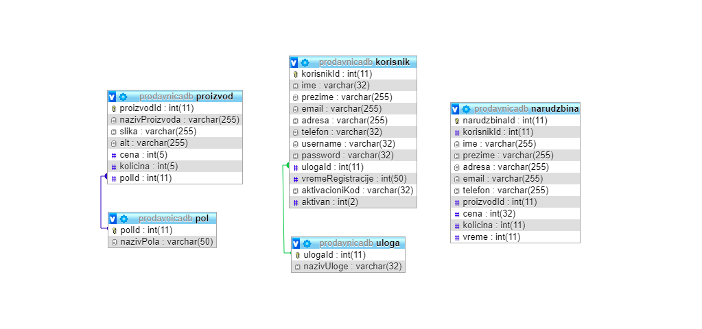

# Slike sajta

## Admin

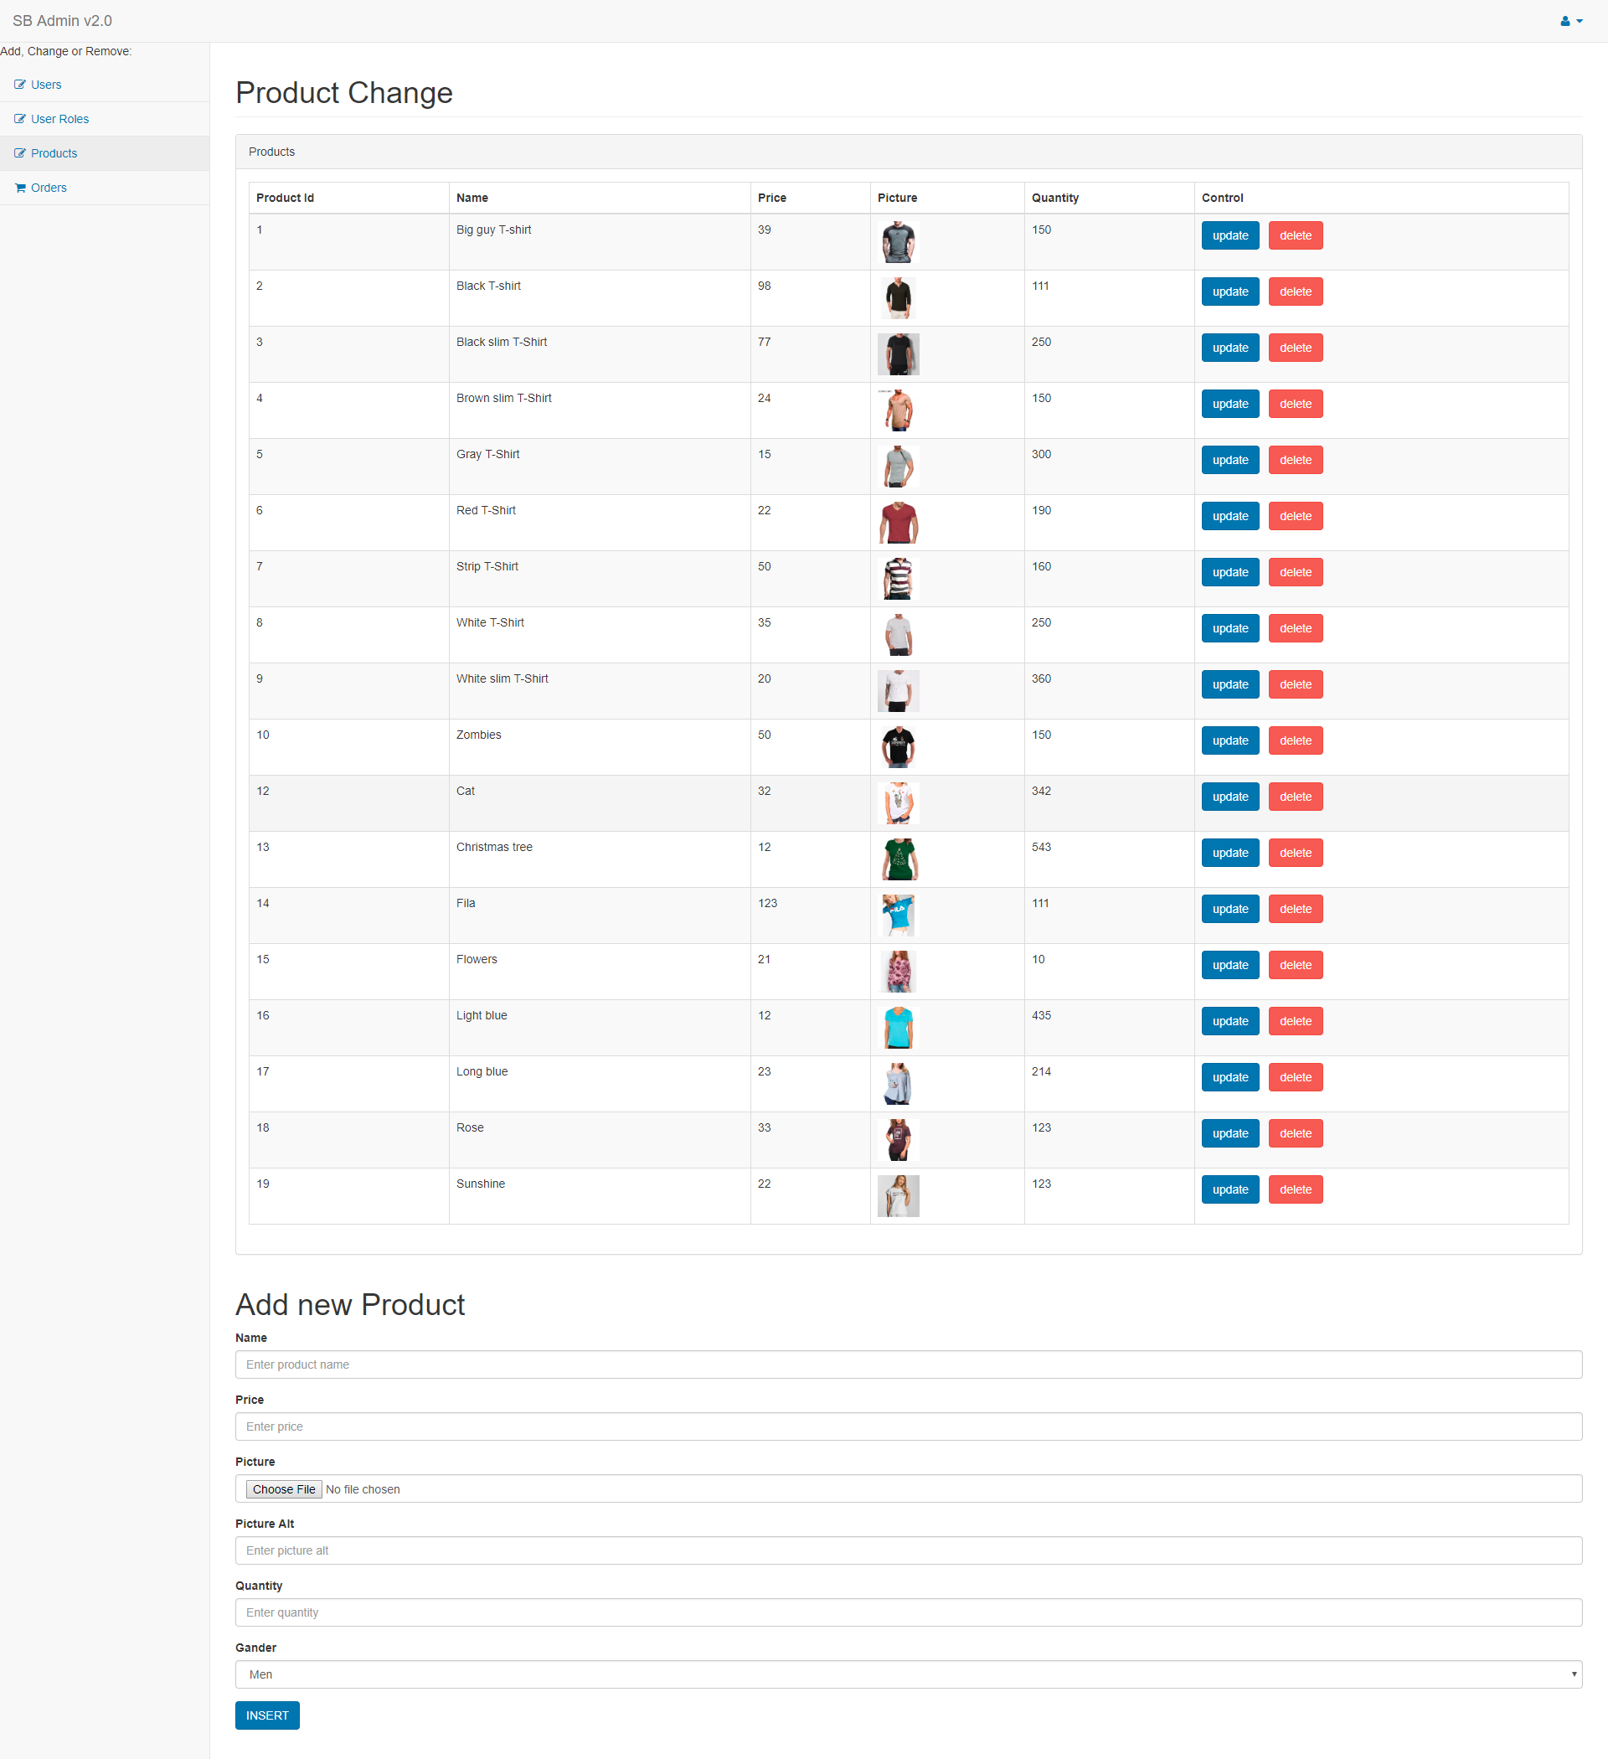

## Index

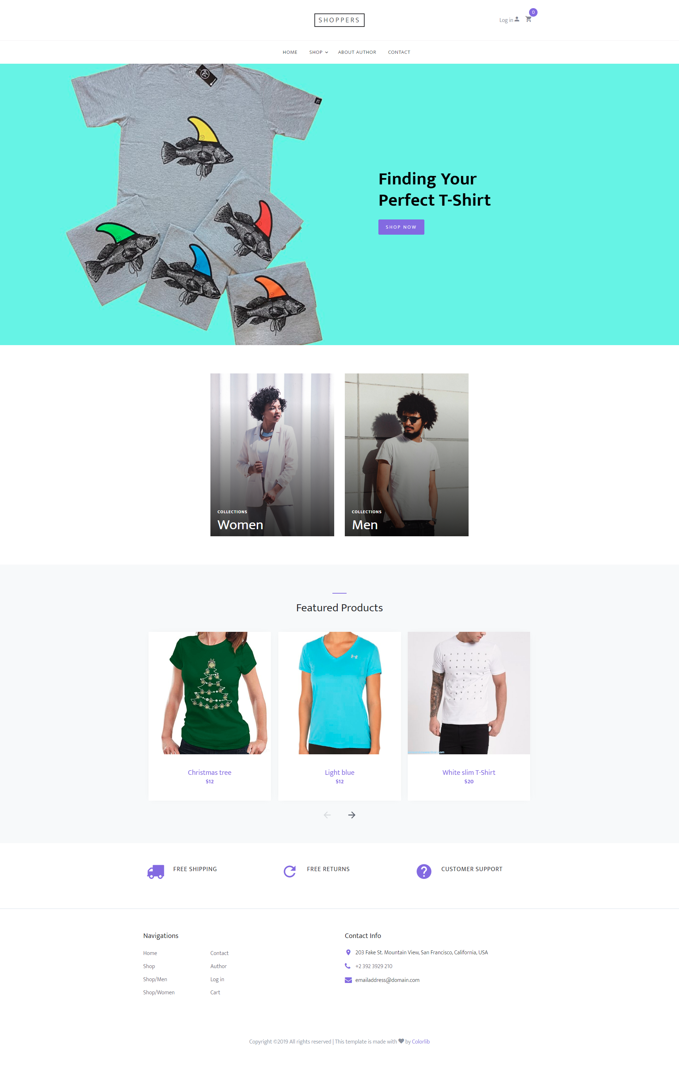

# Shop

# 

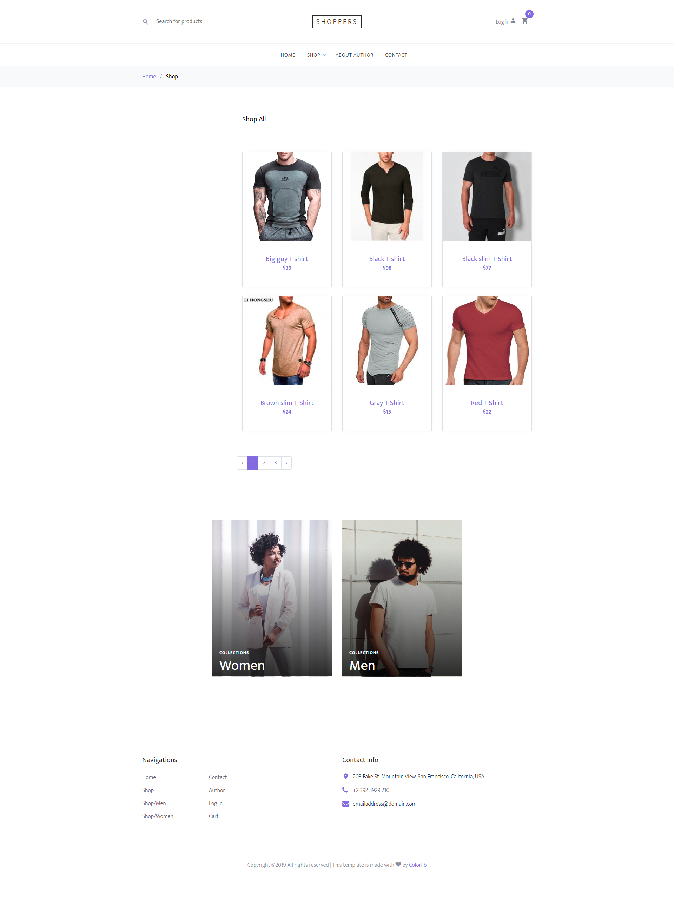

## SingleProduct

## 

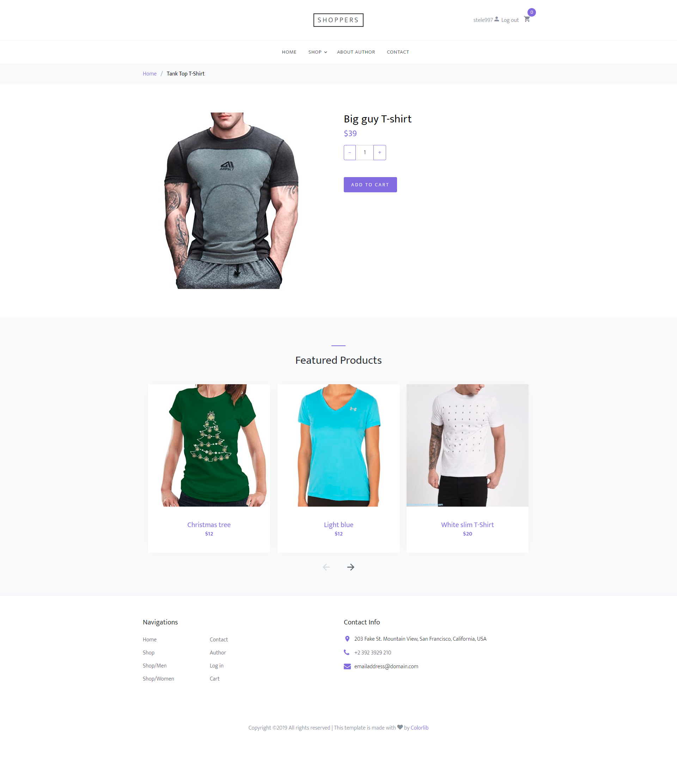

## Cart

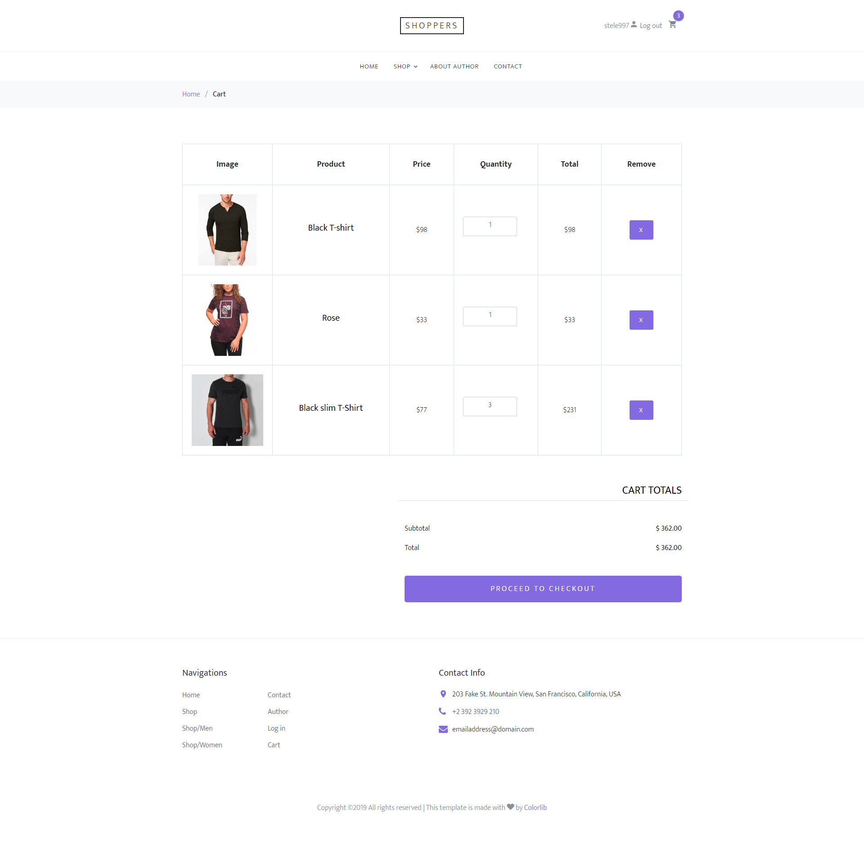

## Checkout

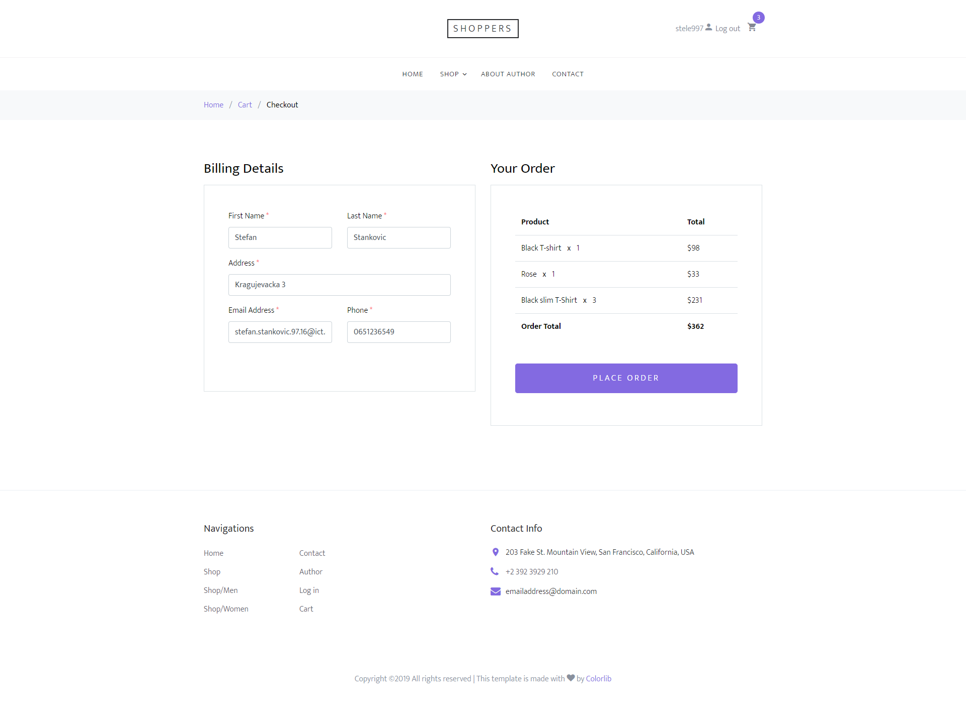

## Login

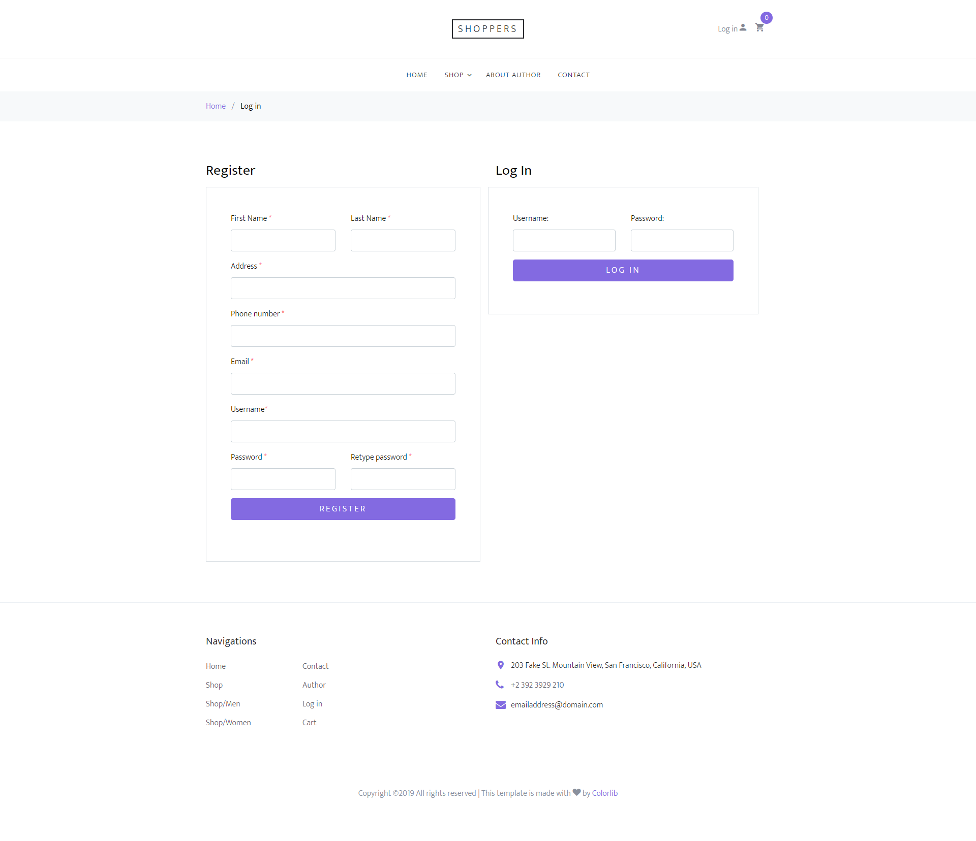

## Contact

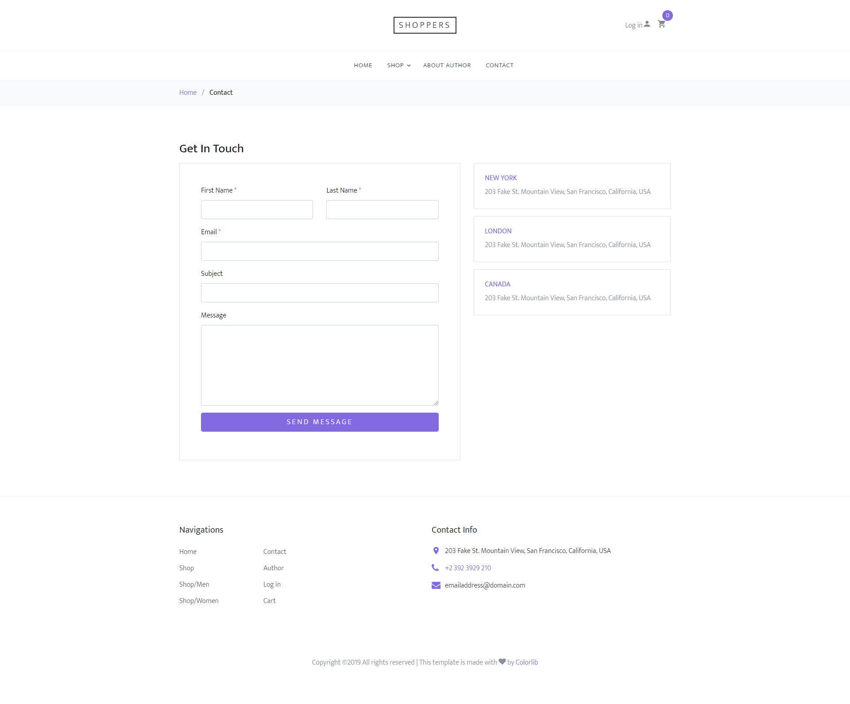

## Author

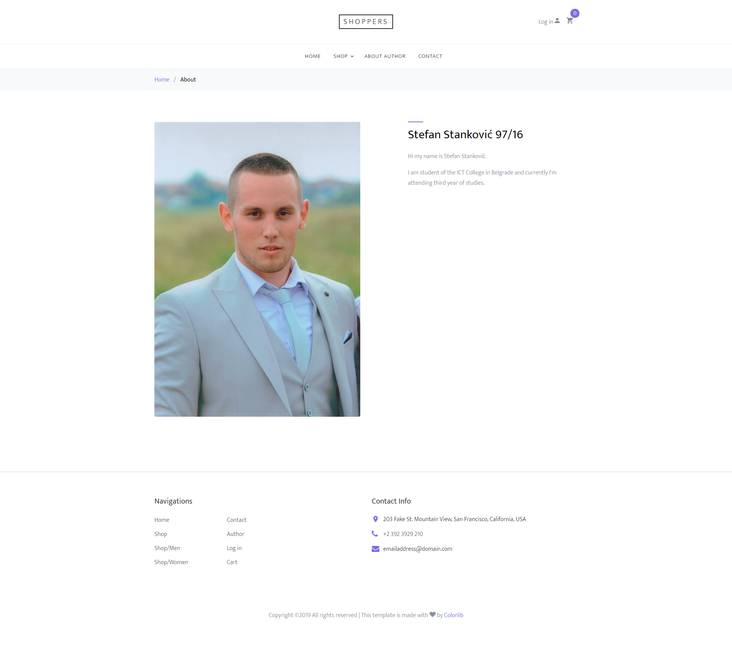

# Kodovi

## Web.php

Route::*get*('/','FrontEndController@index')->named('index');  
Route::*get*('/about','FrontEndController@about')->named('about');  
Route::*get*('/contact','FrontEndController@contact')->named('contact');  
Route::*get*('/shop','FrontEndController@shop')->named('shop');  
Route::*get*('/men','FrontEndController@men');  
Route::*get*('/women','FrontEndController@women');  
Route::*get*('/cart','FrontEndController@cart')->named('cart');  
Route::*get*('/checkout','FrontEndController@checkout')->named('checkOut');  
Route::*get*('/thankyou','FrontEndController@thankyou')->named('thankyou');  
Route::*get*('/login/{var?}','FrontEndController@logIn')->named('login');  
Route::*post*('/register','register@register');  
Route::*post*('/login','login@login');  
Route::*get*('/logout','logout@logout');  
Route::*get*('/acctivated/{aktivacioniKod}','FrontEndController@acctivate');  
Route::*get*('/singleProduct/{id}','frontEndController@singleProduct');  
Route::*get*('/cart/{id}/{kolicina}','cart@addToCart');  
Route::*get*('/nesto/{id}','cart@removeFromCart');  
Route::*post*('/naruci','order@naruci');  
Route::*get*('/search','shop@search');  
Route::*get*('/search/men','shop@searchMen');  
Route::*get*('/search/women','shop@searchWomen');  
Route::*get*('/pagination/fetch_data','paginationController@fetch_data');  
Route::*get*('/pagination/men/fetch_data','paginationController@fetch_dataMan');  
Route::*get*('/pagination/women/fetch_data','paginationController@fetch_dataWoman');  
Route::*post*('/sendMessage','contact@sendMessage');  
Route::*get*('/products','BackEndController@proizovd');  
Route::*get*('/users','BackEndController@korisnik');  
Route::*get*('/changeRole','BackEndController@uloga');  
Route::*get*('/orders','BackEndController@narudzbine');  
Route::*post*('/role/insert','RoleController@insert');  
Route::*post*('/role/delete','RoleController@delete');  
Route::*post*('/product/updateForma','ProductController@updateForma');  
Route::*post*('/product/update','ProductController@update');  
Route::*post*('/product/delete','ProductController@delete');  
Route::*post*('/product/insert','ProductController@insert');  
Route::*post*('/user/updateForma','UserController@updateForma');  
Route::*post*('/user/update','UserController@update');  
Route::*post*('/user/delete','UserController@delete');

## Kontroleri

## App\ Http\Controllers\BackEndController

**<?php***/**  
 * Created by PhpStorm.  
 * User: Stele  
 * Date: 3/11/2019  
 * Time: 5:20 PM  
 */***namespace** App\Http\Controllers;  
  
  
**use** App\Models\korisnik;  
**use** App\Models\narudzbina;  
**use** App\Models\pol;  
**use** App\Models\proizvod;  
**use** App\Models\uloga;  
**use** Illuminate\Support\Facades\Session;  
  
**class** BackEndController  
{  
 **public function** proizovd(){  
 **if**(Session::has('user')&&session('user')->first()->ulogaId==1){  
  
 $proizvod = **new** proizvod();  
 $proizvodi = $proizvod->getAllWithoutPagination();  
 $pol = **new** pol();  
 $polovi=$pol->getAll();  
 **return** view('admin.insertProduct',['proizvodi'=>$proizvodi,'polovi'=>$polovi]);  
 }**else** {  
 **return** response('', 404);  
 }  
 }  
 **public function** uloga(){  
 **if**(Session::*has*('user')&&session('user')->first()->ulogaId==1){  
  
 $uloga = **new** uloga();  
 $uloge = $uloga->getAll();  
 **return** view('admin.adminUloga',['uloge'=>$uloge]);  
 }**else** {  
 **return** response('', 404);  
 }  
 }  
 **public function** korisnik(){  
 $korisnik = **new** korisnik();  
 $korisnici = $korisnik->getAll();  
  
 $uloga = **new** uloga();  
 $uloge = $uloga->getAll();  
 **return** view('admin.adminKorisnik',['korisnici'=>$korisnici,'uloge'=>$uloge]);  
 }  
 **public function** narudzbine(){  
 $narudzbina = **new** narudzbina();  
 $narudzbine=$narudzbina->getAll();  
 $proizvod = **new** proizvod();  
 $proizvodi = $proizvod->getAllWithoutPagination();  
 **return** view('admin.adminNarudzbine',['narudzbine'=>$narudzbine,'proizvodi'=>$proizvodi]);  
 }  
}

## App\ Http\Controllers\FrontEndController

**<?php***/**  
 * Created by PhpStorm.  
 * User: Stele  
 * Date: 3/2/2019  
 * Time: 1:39 PM  
 */***namespace** App\Http\Controllers;  
**use** App\Models\korisnik;  
**use** App\Models\pol;  
**use** App\Models\proizvod;  
**use** Illuminate\Support\Facades\Session;  
  
**class** FrontEndController  
{  
 **public function** index(){  
 $proizvod = **new** proizvod();  
 $proizvodi = $proizvod->petProizvoda();  
 **return** view('index',['proizvodi'=>$proizvodi]);  
 }  
 **public function** about(){  
 **return** view('about');  
 }  
 **public function** contact(){  
 **return** view('contact');  
 }  
 **public function** shop(){  
 $proizvod = **new** proizvod();  
 $proizvodi=$proizvod->getAll();  
 **return** view('shop',['proizvodi'=>$proizvodi]);  
 }  
 **public function** men(){  
 $proizvod = **new** proizvod();  
 $pol = **new** pol();  
 $polId = $pol->getIdMen()[0]->polId;  
 $proizvodi=$proizvod->getAllMen($polId);  
 **return** view('men',['proizvodi'=>$proizvodi]);  
 }  
 **public function** women(){  
 $proizvod = **new** proizvod();  
 $pol = **new** pol();  
 $polId = $pol->getIdWomen()[0]->polId;  
 $proizvodi=$proizvod->getAllWomen($polId);  
  
 **return** view('women',['proizvodi'=>$proizvodi]);  
 }  
 **public function** singleProduct($id){  
 $proizvod = **new** proizvod();  
 $result = $proizvod->getOne($id)->first();  
 $proizvodi = $proizvod->petProizvoda();  
 **return** view('singleProduct',['proizvod'=>$result,'proizvodi'=>$proizvodi]);  
 }  
 **public function** cart(){  
 **if**(session('cart')){  
 $kolicina=0;  
 **if**(Session::*has*('cart')){  
 **foreach** (session('cart')**as** $item){  
 $kolicina+=$item[0]->cena*$item['kolicina'];  
 }  
 }  
  
 }**else**{  
 $kolicina=0;  
 }  
 **return** view('cart',['ukupno'=>$kolicina]);  
 }  
 **public function** checkout(){  
 **if**(Session::*has*('cart')){  
 $nizKorpa=\session('cart');  
 $kolicina=0;  
 **for**($i=0;$i<count($nizKorpa);$i++){  
 $kolicina+=$nizKorpa[$i][0]->cena*$nizKorpa[$i]['kolicina'];  
  
 }  
  
 **return** view('checkOut',['korpa'=>$nizKorpa,'ukupno'=>$kolicina]);  
 }  
 **return** view('checkOut');  
 }  
 **public function** thankyou(){  
 **return** view('thankyou');  
 }  
 **public function** logIn($var=""){  
 **return** view('logIn',['poruka'=>$var]);  
 }  
 **public function** acctivate($aktivacioniKod=""){  
 $korisnik = **new** korisnik();  
 $korisnik->acctivate($aktivacioniKod);  
 **return** view('thankYou',['poruka'=>"Your account is acctivated!"]);  
 }  
}

## App\ Http\Controllers\Cart

**<?php***/**  
 * Created by PhpStorm.  
 * User: Stele  
 * Date: 3/6/2019  
 * Time: 4:30 PM  
 */***namespace** App\Http\Controllers;  
  
  
**use** App\Models\proizvod;  
**use** Illuminate\Support\Facades\Session;  
**use** Illuminate\Support\Collection;  
**use** \Psy\Util\Json;  
  
  
**class** cart  
{  
 **public function** addToCart($id,$kolicina){  
 $proizvod = **new** proizvod();  
  
 $result=$proizvod->getOne($id);  
  
 $result['kolicina']=$kolicina;  
 **if**(Session::has('cart')){  
 Session::*push*('cart', $result);  
 }**else**{  
 session()->push('cart',$result);  
 }  
  
 **return** (session('cart'));  
 }  
 **public function** removeFromCart($id)  
 {  
  
 $niz=session('cart');  
 $novaSesija = [];  
 session()->forget('cart');  
 **for**($i=0;$i<count($niz);$i++){  
 **if**($niz[$i][0]->proizvodId!=$id){  
 array_push($novaSesija, $niz[$i]);  
 }  
 }  
 session()->put("cart", $novaSesija);  
 **return** session()->get("cart");  
  
 }  
}

## App\ Http\Controllers\Contact

**<?php***/**  
 * Created by PhpStorm.  
 * User: Stele  
 * Date: 3/8/2019  
 * Time: 5:49 PM  
 */***namespace** App\Http\Controllers;  
  
**use** App\Mail\contactMail;  
**use** Illuminate\Support\Facades\Mail;  
**use** Validator;  
**use** Illuminate\Http\Request;  
  
**class** contact  
{  
 **public function** sendMessage(Request $request){  
 $validator = Validator::*make*($request->all(), [  
 'firstName' => 'required|regex:/^[A-Z][a-z]{2,12}(\s[A-Z][a-z]{2,12})?$/',  
 'lastName' => 'required|regex:/^[A-Z][a-z]{2,12}(\s[A-Z][a-z]{2,12})?$/',  
 'email' => 'required|email',  
 'subject'=>'required|regex:/^[A-Za-z0-9\s\.\,]+$/',  
 'message'=>'required|regex:/^[A-Za-z0-9\s\.\,]+$/',  
 ]);  
  
 **if** ($validator->fails()) {  
 **return** redirect('/login')  
 ->withErrors($validator, 'register')  
 ->withInput();  
 }**else**{  
 $firstName=($request->input('firstName'));  
 $lastName=($request->input('lastName'));  
 $email=($request->input('email'));  
 $naslov=($request->input('subject'));  
 $message=($request->input('message'));  
  
 Mail::*to*('stefan.stankovic.97.16@ict.edu.rs')->send(**new** contactMail($firstName,$lastName,$email,$naslov,$message));  
 **return** redirect('contact/Your mail is sent to the administrator!');  
 }  
  
 // Store the blog post...  
  
 }  
}

## App\ Http\Controllers\Login

**<?php***/**  
 * Created by PhpStorm.  
 * User: Stele  
 * Date: 3/3/2019  
 * Time: 4:59 PM  
 */***namespace** App\Http\Controllers;  
  
**use** Validator;  
**use** Illuminate\Http\Request;  
**use** App\Http\Controllers\Controller;  
**use** App\Models\korisnik;  
  
**class** login **extends** Controller  
{  
 */**  
 * Store a new blog post.  
 *  
 \** ***@param*** *Request $request  
 \** ***@return*** *Response  
 */* **public function** login(Request $request)  
 {  
 $validator = Validator::*make*($request->all(), [  
 'loginUsername' => 'required|regex:/^[A-Za-z]{1}[A-Za-z0-9]{2,14}$/',  
 'loginPassword' => 'required|regex:/^[\S]{6,25}$/'  
 ]);  
  
 **if** ($validator->fails()) {  
 **return** redirect('/login')  
 ->withErrors($validator, 'login')  
 ->withInput();  
 }**else**{  
 $username=($request->input('loginUsername'));  
 $password=md5($request->input('loginPassword'));  
  
 $korisnik = **new** korisnik();  
 **try**{  
 $result=$korisnik->login($username,$password);  
 **if**(count($result)>0){  
 session(**array**('user' => $result));  
 **if**(session('user')->first()->ulogaId==1){  
 **return** redirect('/products');  
 }  
 **else**{  
 **return** redirect('/');  
 }  
 }**else**{  
 **return** redirect('/login');  
 }  
 }**catch** (mysqli_sql_exception $e){  
  
 }  
  
  
  
 **return** redirect('/');  
 }  
  
 // Store the blog post...  
 }  
}

## App\ Http\Controllers\Logout

**<?php***/**  
 * Created by PhpStorm.  
 * User: Stele  
 * Date: 3/4/2019  
 * Time: 12:00 PM  
 */***namespace** App\Http\Controllers;  
  
  
**use** Illuminate\Http\Request;  
  
**class** logout  
{  
 **public function** logout(Request $request){  
 $request->session()->forget('user');  
 **return** redirect("/");  
 }  
}

## App\ Http\Controllers\Order

**<?php***/**  
 * Created by PhpStorm.  
 * User: Stele  
 * Date: 3/7/2019  
 * Time: 9:46 PM  
 */***namespace** App\Http\Controllers;  
  
  
**use** App\Models\narudzbina;  
**use** App\Models\proizvod;  
**use** Validator;  
**use** Illuminate\Http\Request;  
  
**class** order  
{  
 **public function** naruci(Request $request)  
 {  
 $validator = Validator::*make*($request->all(), [  
 'firstName' => 'required|regex:/^[A-Z][a-z]{2,12}(\s[A-Z][a-z]{2,12})?$/',  
 'lastName' => 'required|regex:/^[A-Z][a-z]{2,12}(\s[A-Z][a-z]{2,12})?$/',  
 'address' => 'required|regex:/^[A-Z][a-z]{2,15}(\s[A-Z][a-z]{2,15})*\s[0-9]{1,4}(\/[0-9]{1,4})?$/',  
 'phone' => 'required|regex:/^06[0-9]{1}[0-9]{6}([0-9]{1})?$/',  
 'email' => 'required|email'  
 ]);  
  
 **if** ($validator->fails()) {  
 **return** redirect('/checkout')  
 ->withErrors($validator, 'register')  
 ->withInput();  
 }**else**{  
 $firstName=($request->input('firstName'));  
 $lastName=($request->input('lastName'));  
 $address=($request->input('address'));  
 $phone=($request->input('phone'));  
 $email=($request->input('email'));  
 $vremePorudzbine=time();  
  
 $korisnikId=session('user')->first()->korisnikId;  
 $narudzbine = session('cart');  
 $narudzbina=**new** narudzbina();  
 **foreach** ($narudzbine **as** $item){  
  
 $proizvodId=$item[0]->proizvodId;  
 $cena=$item[0]->cena;  
 $kolicina=$item['kolicina'];  
 $narudzbina->ubaciNarudzbinu($korisnikId,$firstName,$lastName,$address,$email,$phone,$vremePorudzbine,$proizvodId,$cena,$kolicina);  
 session()->forget('cart');  
 }  
 **return** redirect('/');  
 }  
  
 // Store the blog post...  
 }  
}

## App\ Http\Controllers\paginationController

**<?php***/**  
 * Created by PhpStorm.  
 * User: Stele  
 * Date: 3/8/2019  
 * Time: 4:02 PM  
 */***namespace** App\Http\Controllers;  
  
  
**use** App\Models\proizvod;  
**use** Illuminate\Http\Request;  
  
**class** paginationController  
{  
 **public function** fetch_data(Request $request){  
 **if**($request->ajax()){  
 $proizvod = **new** proizvod();  
 $proizvodi=$proizvod->getAll();  
 **return** view('inc.listaProizvodaZaShop',compact('proizvodi'))->render();  
 }  
 }  
 **public function** fetch_dataMan(Request $request){  
 **if**($request->ajax()){  
 $proizvod = **new** proizvod();  
 $proizvodi=$proizvod->getAllMen();  
 **return** view('inc.listaProizvodaZaShop',compact('proizvodi'))->render();  
 }  
 }  
 **public function** fetch_dataWoman(Request $request){  
 **if**($request->ajax()){  
 $proizvod = **new** proizvod();  
 $proizvodi=$proizvod->getAllWomen();  
 **return** view('inc.listaProizvodaZaShop',compact('proizvodi'))->render();  
 }  
 }  
}

## App\ Http\Controllers\productController

**<?php***/**  
 * Created by PhpStorm.  
 * User: Stele  
 * Date: 3/12/2019  
 * Time: 1:27 PM  
 */***namespace** App\Http\Controllers;  
  
  
**use** App\Models\pol;  
**use** App\Models\proizvod;  
**use** Illuminate\Http\Request;  
**use** Illuminate\Support\Facades\Storage;  
  
**class** ProductController  
{  
 **public function** insert(Request $request){  
 $naziv= $request->post('naziv');  
 $cena= $request->post('cena');  
 $slika_alt= $request->post('slika_alt');  
 $kolicina= $request->post('kolicina');  
 $pol=$request->post('pol');  
 $slika = $request->file('slika');  
 $fileName = $slika->getClientOriginalName();  
 $fileName = time().'_'.$fileName;  
 **try** {  
 $slika->move(public_path('images'), $fileName);  
 $product = **new** proizvod();  
 $product->insert($naziv,$cena,$fileName,$slika_alt,$kolicina,$pol);  
 **return** redirect('/products');  
  
 }**catch**(Exception $e){  
  
 }  
 }  
  
 **public function** updateForma(Request $request){  
 $id=$request->post('id');  
 $proizovd= **new** proizvod();  
 $pol= **new** pol();  
 $polovi = $pol->getAll();  
 $proizvodi['proizvod']= $proizovd->getOne($id);  
 $proizvodi['polovi']=$polovi;  
 **return** $proizvodi;  
 }  
  
 **public function** update(Request $request){  
 $id=$request->post('id');  
 $naziv= $request->post('naziv');  
 $cena= $request->post('cena');  
 $slika_alt= $request->post('slika_alt');  
 $kolicina= $request->post('kolicina');  
 $pol=$request->post('pol');  
  
 $slika = $request->file('slika');  
 **if**($slika==**null**){  
  
 $proizvod= **new** proizvod();  
 $proizvod->updateBezSlika($id,$naziv,$cena,$slika_alt,$kolicina,$pol);  
 **return** redirect('/products');  
 }**else**{  
 $slika = $request->file('slika');  
 $fileName = $slika->getClientOriginalName();  
 $fileName = time().'_'.$fileName;  
 **try** {  
 $slika->move(public_path('images'), $fileName);  
 $product = **new** proizvod();  
 $product->update($id,$naziv,$fileName,$cena,$slika_alt,$kolicina,$pol);  
 **return** redirect('/products');  
  
 }**catch**(Exception $e){  
  
 }  
 }  
  
 }  
  
 **public function** delete(Request $request){  
 $id=$request->post('id');  
 $proiuzvod = **new** proizvod();  
 $proiuzvod->delete($id);  
 $proizvodi = $proiuzvod->getAllWithoutPagination();  
 **return** $proizvodi;  
 }  
}

## App\ Http\Controllers\Register

**<?php***/**  
 * Created by PhpStorm.  
 * User: Stele  
 * Date: 3/3/2019  
 * Time: 4:59 PM  
 */***namespace** App\Http\Controllers;  
  
**use** App\Mail\ActivateAccount;  
**use** Illuminate\Support\Facades\Mail;  
**use** Validator;  
**use** Illuminate\Http\Request;  
**use** App\Http\Controllers\Controller;  
**use** App\Models\korisnik;  
  
**class** register **extends** Controller  
{  
 */**  
 * Store a new blog post.  
 *  
 \** ***@param*** *Request $request  
 \** ***@return*** *Response  
 */* **public function** register(Request $request)  
 {  
 $validator = Validator::*make*($request->all(), [  
 'firstName' => 'required|regex:/^[A-Z][a-z]{2,12}(\s[A-Z][a-z]{2,12})?$/',  
 'lastName' => 'required|regex:/^[A-Z][a-z]{2,12}(\s[A-Z][a-z]{2,12})?$/',  
 'address' => 'required|regex:/^[A-Z][a-z]{2,15}(\s[A-Z][a-z]{2,15})*\s[0-9]{1,4}(\/[0-9]{1,4})?$/',  
 'phone' => 'required|regex:/^06[0-9]{1}[0-9]{6}([0-9]{1})?$/',  
 'email' => 'required|email',  
 'username' => 'required|unique:korisnik,username|regex:/^[A-Za-z]{1}[A-Za-z0-9]{2,14}$/',  
 'password' => 'required|regex:/^[\S]{6,25}$/'  
 ]);  
  
 **if** ($validator->fails()) {  
 **return** redirect('/login')  
 ->withErrors($validator, 'register')  
 ->withInput();  
 }**else**{  
 $firstName=($request->input('firstName'));  
 $lastName=($request->input('lastName'));  
 $address=($request->input('address'));  
 $phone=($request->input('phone'));  
 $email=($request->input('email'));  
 $username=($request->input('username'));  
 $password=md5($request->input('password'));  
 $vremeRegistrivanja=time();  
 $aktivacioniKod=md5($vremeRegistrivanja.$email);  
  
 $korisnik = **new** korisnik();  
 $korisnik->register($firstName,$lastName,$email,$address,$phone,$username,$password,$vremeRegistrivanja,$aktivacioniKod);  
 Mail::*to*($email)->send(**new** ActivateAccount($aktivacioniKod));  
 **return** redirect('/login/Acctivate your account');  
 }  
  
 // Store the blog post...  
 }  
}

## App\Http\Controllers\roleController

**<?php***/**  
 * Created by PhpStorm.  
 * User: Stele  
 * Date: 3/11/2019  
 * Time: 7:16 PM  
 */***namespace** App\Http\Controllers;  
  
  
  
**use** App\Models\uloga;  
**use** Illuminate\Http\Request;  
  
**class** RoleController  
{  
 **public function** insert(Request $request){  
  
 $nazivRole= $request->post('naziv');  
 $uloga = **new** uloga();  
 $uloga->insert($nazivRole);  
 $uloge=$uloga->getAll();  
 **return** $uloge;  
 }  
 **public function** delete(Request $request){  
  
 $id= $request->post('id');  
 $uloga = **new** uloga();  
 $uloga->delete($id);  
 $uloge=$uloga->getAll();  
 **return** $uloge;  
 }  
}

## App\Http\Controllers\Shop

**<?php***/**  
 * Created by PhpStorm.  
 * User: Stele  
 * Date: 3/8/2019  
 * Time: 3:30 PM  
 */***namespace** App\Http\Controllers;  
  
  
**use** App\Models\proizvod;  
**use** Illuminate\Http\Request;  
  
**class** shop  
{  
 **public function** search(Request $request){  
 $query= $request->get('query') ;  
 **if**($query!=''){  
 $proizvod = **new** proizvod();  
 $proizvodi=$proizvod->findOnName($query);  
 **return** view('inc.listaProizvodaZaShop',compact('proizvodi'))->render();  
 }**else**{  
 **if**($request->ajax()){  
 $proizvod = **new** proizvod();  
 $proizvodi=$proizvod->getAll();  
 **return** view('inc.listaProizvodaZaShop',compact('proizvodi'))->render();  
 }  
 }  
 }  
  
 **public function** searchMen(Request $request){  
 $query= $request->get('query') ;  
 **if**($query!=''){  
 $proizvod = **new** proizvod();  
 $proizvodi=$proizvod->findOnNameMan($query);  
 **return** view('inc.listaProizvodaZaShop',compact('proizvodi'))->render();  
 }**else**{  
 **if**($request->ajax()){  
 $proizvod = **new** proizvod();  
 $proizvodi=$proizvod->getAllMen();  
 **return** view('inc.listaProizvodaZaShop',compact('proizvodi'))->render();  
 }  
 }  
 }  
 **public function** searchWomen(Request $request){  
 $query= $request->get('query') ;  
 **if**($query!=''){  
 $proizvod = **new** proizvod();  
 $proizvodi=$proizvod->findOnNameWomen($query);  
 **return** view('inc.listaProizvodaZaShop',compact('proizvodi'))->render();  
 }**else**{  
 **if**($request->ajax()){  
 $proizvod = **new** proizvod();  
 $proizvodi=$proizvod->getAllWomen();  
 **return** view('inc.listaProizvodaZaShop',compact('proizvodi'))->render();  
 }  
 }  
 }  
}

## App\Http\Controllers\userController

**<?php***/**  
 * Created by PhpStorm.  
 * User: Stele  
 * Date: 3/13/2019  
 * Time: 1:21 PM  
 */***namespace** App\Http\Controllers;  
  
  
**use** App\Models\korisnik;  
**use** App\Models\uloga;  
**use** Illuminate\Http\Request;  
  
**class** UserController  
{  
 **public function** updateForma(Request $request){  
 $id=$request->post('id');  
 $korisnik = **new** korisnik();  
 $korisnici['korisnici'] = $korisnik->getOne($id);  
  
 $uloga = **new** uloga();  
 $korisnici['uloge'] = $uloga->getAll();  
  
 **return** $korisnici;  
 }  
 **public function** update(Request $request){  
 $id = $request->post('id');  
 $ime= $request->post('ime');  
 $prezime= $request->post('prezime');  
 $adresa= $request->post('adresa');  
 $telefon= $request->post('telefon');  
 $email= $request->post('email');  
 $username= $request->post('username');  
 $aktivan= $request->post('aktivan');  
 $uloga= $request->post('uloga');  
 $korisnik = **new** korisnik();  
 $korisnik->update($id,$ime,$prezime,$adresa,$telefon,$email,$username,$aktivan,$uloga);  
 $podaci['korisnici'] = $korisnik->getAll();  
 $uloga = **new** uloga();  
 $podaci['uloge'] = $uloga->getAll();  
  
 **return** $podaci;  
 }  
  
 **public function** delete(Request $request){  
 $id=$request->post('id');  
 $korisnik = **new** korisnik();  
 $korisnik->delete($id);  
 $podaci['korisnici'] = $korisnik->getAll();  
 $uloga = **new** uloga();  
 $podaci['uloge'] = $uloga->getAll();  
  
 **return** $podaci;  
 }  
}

# Modeli

## App\Http\Models\korisnik

**<?php***/**  
 * Created by PhpStorm.  
 * User: Stele  
 * Date: 3/3/2019  
 * Time: 6:40 PM  
 */***namespace** App\Models;  
  
  
**use** Illuminate\Support\Facades\DB;  
  
**class** korisnik  
{  
 **public function** register($ime, $prezime,$email, $adresa, $telefon, $username, $password, $vremeRegistracije, $aktivacioniKod ){  
 DB::*table*('korisnik')->insert(['ime'=>$ime,'prezime'=>$prezime,'email'=>$email,'adresa'=>$adresa,'telefon'=>$telefon,'username'=>$username,  
 'password'=>$password,'vremeRegistracije'=>$vremeRegistracije,'aktivacioniKod'=>$aktivacioniKod,'ulogaid'=>'2']);  
 }  
  
 **public function** login($username, $password){  
 **return** DB::table('korisnik')  
 ->where([  
 ['username',$username],  
 ['password',$password],  
 ['aktivan', 1],  
 ])->get();  
 }  
 **public function** acctivate($aktivacioniKod){  
 DB::*table*('korisnik')->where('aktivacioniKod','=',$aktivacioniKod)->update(['aktivan' => 1]);  
 }  
  
 **public function** getAll(){  
 **return** DB::*table*('korisnik')->get();  
 }  
 **public function** getOne($id){  
 **return** DB::table('korisnik')->where(['korisnikId'=>$id])->get();  
 }  
 **public function** update($id,$ime,$prezime,$adresa,$telefon,$email,$username,$aktivan,$uloga){  
 DB::*table*('korisnik')->where('korisnikId','=',$id)->update(['ime'=>$ime,'prezime'=>$prezime,  
 'adresa'=>$adresa,'telefon'=>$telefon,'email'=>$email,'username'=>$username,'aktivan'=>$aktivan,'ulogaId'=>$uloga]);  
 }  
 **public function** delete($id){  
 DB::table('korisnik')->where(['korisnikId'=>$id])->delete();  
 }  
}

## App\Http\Models\Narudzbina

**<?php***/**  
 * Created by PhpStorm.  
 * User: Stele  
 * Date: 3/7/2019  
 * Time: 9:56 PM  
 */***namespace** App\Models;  
  
  
**use** Illuminate\Support\Facades\DB;  
  
**class** narudzbina  
{  
 **public function** ubaciNarudzbinu($korisnikId,$ime,$prezime,$adresa,$email,$telefon,$vreme,$proizvodId,$cena,$kolicina){  
 DB::table('narudzbina')->insert([  
 'korisnikId'=>$korisnikId,  
 'ime'=>$ime,  
 'prezime'=>$prezime,  
 'adresa'=>$adresa,  
 'email'=>$email,  
 'telefon'=>$telefon,  
 'vreme'=>$vreme,  
 'proizvodId'=>$proizvodId,  
 'cena'=>$cena,  
 'kolicina'=>$kolicina  
 ]);  
 }  
 **public function** getAll(){  
 **return** DB::*table*('narudzbina')->get();  
 }  
}

## App\Http\Models\Pol

**<?php***/**  
 * Created by PhpStorm.  
 * User: Stele  
 * Date: 3/12/2019  
 * Time: 2:23 PM  
 */***namespace** App\Models;  
  
  
**use** Illuminate\Support\Facades\DB;  
  
**class** pol  
{  
 **public function** getAll(){  
 **return** DB::*table*('pol')->get();  
 }  
 **public function** getIdMen(){  
 **return** DB::*table*('pol')->where('nazivPola','=','men')->get('polId');  
 }  
 **public function** getIdWomen(){  
 **return** DB::*table*('pol')->where('nazivPola','=','women')->get('polId');  
 }  
}

## App\Http\Models\Proizvod

**<?php***/**  
 * Created by PhpStorm.  
 * User: Stele  
 * Date: 3/5/2019  
 * Time: 7:10 PM  
 */***namespace** App\Models;  
  
**use** Illuminate\Support\Facades\DB;  
**class** proizvod  
{  
 **public function** getAll(){  
 **return** DB::table('proizvod')->paginate(6);  
 }  
 **public function** getAllMen(){  
 **return** DB::table('proizvod')->where(['polId'=>1])->paginate(6);  
 }  
 **public function** getAllWomen(){  
 **return** DB::table('proizvod')->where(['polId'=>2])->paginate(6);  
 }  
 **public function** getAllWithoutPagination(){  
 **return** DB::*table*('proizvod')->get();  
 }  
 **public function** getOne($id){  
 **return** DB::table('proizvod')->where('proizvodId','=',$id)->get();  
 }  
 **public function** findOnName($string){  
 **return** DB::*table*('proizvod')->where('nazivProizvoda','like','%'.$string.'%')->paginate(6);  
 }  
 **public function** findOnNameMan($string){  
 **return** DB::table('proizvod')->where([['nazivProizvoda','like','%'.$string.'%'],['polId','=',1]])->paginate(6);  
 }  
 **public function** findOnNameWomen($string){  
 **return** DB::*table*('proizvod')->where([['nazivProizvoda','like','%'.$string.'%'],['polId','=',2]])->paginate(6);  
 }  
 **public function** insert($naziv, $cena,$slika,$slikaAlt,$kolicina,$pol){  
 DB::*table*('proizvod')->insert(['nazivProizvoda'=>$naziv,'cena'=>$cena,'slika'=>$slika,'alt'=>$slikaAlt,'kolicina'=>$kolicina,'polId'=>$pol]);  
 }  
 **public function** updateBezSlika($id,$naziv, $cena,$slikaAlt,$kolicina,$pol){  
 DB::*table*('proizvod')->where('proizvodId','=',$id)->update(['nazivProizvoda'=>$naziv,'cena'=>$cena,'alt'=>$slikaAlt,'kolicina'=>$kolicina,'polId'=>$pol]);  
 }  
 **public function** update($id,$naziv,$slika, $cena,$slikaAlt,$kolicina,$pol){  
 DB::table('proizvod')->where('proizvodId','=',$id)->update(['nazivProizvoda'=>$naziv,'cena'=>$cena,'slika'=>$slika,'alt'=>$slikaAlt,'kolicina'=>$kolicina,'polId'=>$pol]);  
 }  
 **public function** delete($id){  
 **return** DB::table('proizvod')->where('proizvodId','=',$id)->delete();  
 }  
 **public function** petProizvoda(){  
 **return** DB::table('proizvod')->orderBy('kolicina','desc')->limit(5)->get();  
 }  
}

## App\Http\Models\Uloga

**<?php***/**  
 * Created by PhpStorm.  
 * User: Stele  
 * Date: 3/11/2019  
 * Time: 7:03 PM  
 */***namespace** App\Models;  
  
  
**use** Illuminate\Support\Facades\DB;  
  
**class** uloga  
{  
 **public function** getAll(){  
 **return** DB::*table*('uloga')->get();  
 }  
 **public function** insert($naziv){  
 DB::*table*('uloga')->insert(['nazivUloge'=>$naziv]);  
 }  
 **public function** delete($id){  
 DB::table('uloga')->where('ulogaId', '=', $id)->delete();  
 }  
}

# Views

## Templates

## Resources\Views\Templates\Template.blade.php

**@include(**'inc.head'**)  
@include(**'inc.header'**)  
  
@yield(**'sadrzaj'**)  
  
  
  
  
  
  
@include(**'inc.footer'**)**

## Resources\Views\Templates\adminTemplate.blade.php

**@include(**'inc.admin-head'**)  
@include(**'inc.admin-nav'**)  
  
@yield(**'sadrzaj'**)  
@include(**'inc.admin-footer'**)**

## Resources\Views\About.blade.php

**@extends(**'templates.template'**)  
@section(**'sadrzaj'**)  
 @include(**'inc.fileNameTrack'**)  
 @include(**'inc.aboutAndTeam'**)  
 @endsection**

## Resources\Views\Cart.blade.php

**@extends(**'templates.template'**)  
@section(**'sadrzaj'**)  
@include(**'inc.cart'**)  
@endsection  
@section(**'js'**)** <script src={{ URL::*asset*("js/cart.js") }}></script>  
 **@endsection**

## Resources\Views\Checkout.blade.php

**@extends(**'templates.template'**)  
@section(**'sadrzaj'**)  
@include(**'inc.checkout'**)  
@endsection  
@section(**'js'**)** <script src={{ URL::*asset*("js/checkout.js") }}></script>  
 **@endsection**

## Resources\Views\Contact.blade.php

**@extends(**'templates.template'**)  
@section(**'sadrzaj'**)  
@include(**'inc.contactForm'**)  
@endsection  
@section(**'js'**)** <script src={{ URL::*asset*("js/contact.js") }}></script>  
 **@endsection**

## Resources\Views\ContactEmail.blade.php

<h1>{{$ime." ".$prezime.','. $email}}</h1>  
<h1>{{$subject}}</h1>  
<p>{{$poruka}}</p>

## Resources\Views\Email.blade.php

<h1>Hi there</h1>  
<p>To acctivate your account click here --> <a href="http://127.0.0.1:8000/acctivated/{{$aktivacija}}">Acctivate</a></p>

## Resources\Views\Index.blade.php

**@extends(**'templates.template'**)  
@section(**'sadrzaj'**)  
 @include(**'inc.indexSlider'**)  
 @include(**'inc.categories'**)  
 @include(**'inc.featuredProducts'**)  
 @include(**'inc.costumerSupport'**)  
@endsection**

## Resources\Views\Login.blade.php

**@extends(**'templates.template'**)  
@section(**'sadrzaj'**)  
 @include(**'inc.logIn'**)  
@endsection  
@section(**'js'**)** <script src={{ URL::*asset*("js/login.js") }}></script>  
**@endsection**

## Resources\Views\Men.blade.php

**@extends(**'templates.template'**)  
@section(**'sadrzaj'**)  
 @include(**'inc.men'**)  
@endsection  
@section(**'search'**)** <form action="" class="site-block-top-search">  
 <span class="icon icon-search2"></span>  
 <input type="text" class="form-control border-0" id="searchProducts" placeholder="Search for products">  
 </form>  
**@endsection  
@section(**'js'**)** <script src={{ URL::*asset*("js/men.js") }}></script>  
**@endsection**

## Resources\Views\Shop.blade.php

**@extends(**'templates.template'**)  
@section(**'sadrzaj'**)  
@include(**'inc.shop'**)  
@endsection  
@section(**'search'**)** <form action="" class="site-block-top-search">  
 <span class="icon icon-search2"></span>  
 <input type="text" class="form-control border-0" id="searchProducts" placeholder="Search for products">  
 </form>  
 **@endsection  
@section(**'js'**)** <script src={{ URL::*asset*("js/shop.js") }}></script>  
 **@endsection**

## Resources\Views\singleProduct.blade.php

**@extends(**'templates.template'**)  
@section(**'sadrzaj'**)  
 @include(**'inc.singleProduct'**)  
@endsection  
@section(**'js'**)** <script src={{ URL::*asset*("js/singleProduct.js") }}></script>  
**@endsection**

## Resources\Views\Thankyou.blade.php

**@extends(**'templates.template'**)  
@section(**'sadrzaj'**)  
 @include(**'inc.thankyou'**)  
@endsection**

## Resources\Views\Women.blade.php

**@extends(**'templates.template'**)  
@section(**'sadrzaj'**)  
 @include(**'inc.women'**)  
@endsection  
@section(**'search'**)** <form action="" class="site-block-top-search">  
 <span class="icon icon-search2"></span>  
 <input type="text" class="form-control border-0" id="searchProducts" placeholder="Search for products">  
 </form>  
**@endsection  
@section(**'js'**)** <script src={{ URL::*asset*("js/women.js") }}></script>  
**@endsection**

## Resources\Views\Admin\adminKorisnik.blade.php

**@extends(**'templates.adminTemplate'**)  
@section(**'sadrzaj'**)** <div class="row">  
 <div class="col-lg-12">  
 <h1 class="page-header">Users Change</h1>  
 </div>  
 <!-- /.col-lg-12 -->  
 </div>  
 <!-- /.row -->  
 <div class="row">  
 <div class="col-lg-12">  
  
 <div class="panel panel-default">  
 <div class="panel-heading">  
 Users  
 </div>  
 <div class="panel-body">  
 <table width="100%" class="table table-striped table-bordered table-hover" id="dataTables-example">  
 <thead>  
 <tr>  
 <th>User Id</th>  
 <th>Name</th>  
 <th>Last name</th>  
 <th>Address</th>  
 <th>Phone number</th>  
 <th>Email</th>  
 <th>Username</th>  
 <th>Date of registration</th>  
 <th>Acctive</th>  
 <th>Uloga</th>  
 <th>Control</th>  
 </tr>  
 </thead>  
 <tbody>  
 **@foreach(**$korisnici **as** $user**)** <tr class="odd gradeX">  
 <td>{{$user->korisnikId}}</td>  
 <td>{{$user->ime}}</td>  
 <td>{{$user->prezime}}</td>  
 <td class="center">{{$user->adresa}}</td>  
 <td class="center">{{$user->telefon}}</td>  
 <td class="center">{{$user->email}}</td>  
 <td class="center">{{$user->username}}</td>  
 <td class="center">{{date('d.m.Y',$user->vremeRegistracije)}}</td>  
 <td class="center">  
 **@if(**$user->aktivan==1**)** aktivan  
 **@else** nije aktivan  
 **@endif** </td>  
 **@foreach(**$uloge **as** $u**)  
 @if(**$u->ulogaId==$user->ulogaId**)** <td class="center">{{$u->nazivUloge}}</td>  
 **@endif  
  
 @endforeach** <td><input class="btn btn-primary btn-md user-update" data-id="{{$user->korisnikId}}" type="button" value="update"/> &nbsp;  
 <input class="btn btn-danger btn-md user-delete" data-id="{{$user->korisnikId}}" type="button" value="delete"/></td>  
 </tr>  
 **@endforeach** </tbody>  
 </table>  
 </div>  
 </div>  
 <div id="ispisiOvde" class="row">  
  
 <!-- /.col-lg-6 (nested) -->  
 </div>  
 <!-- /.row (nested) -->  
 </div>  
 <!-- /.panel-body -->  
 </div>  
 <!-- /.panel -->  
 </div>  
 <!-- /.col-lg-12 -->  
 </div>  
 <!-- /.row -->  
 **@endsection**

## Resources\Views\Admin\adminNarudzbine.blade.php

**@extends(**'templates.adminTemplate'**)  
@section(**'sadrzaj'**)** <div class="row">  
 <div class="col-lg-12">  
 <h1 class="page-header">All orders</h1>  
 </div>  
 <!-- /.col-lg-12 -->  
 </div>  
 <!-- /.row -->  
 <div class="row">  
 <div class="col-lg-12">  
  
 <div class="panel panel-default">  
 <div class="panel-heading">  
 Orders  
 </div>  
 <div class="panel-body">  
 <table width="100%" class="table table-striped table-bordered table-hover" id="dataTables-example">  
 <thead>  
 <tr>  
 <th>Name</th>  
 <th>Last Name</th>  
 <th>Address</th>  
 <th>Phone number</th>  
 <th>Products</th>  
 <th>Quantity</th>  
 <th>Price</th>  
 <th>Time of order</th>  
 </tr>  
 </thead>  
 <tbody>  
 **@foreach(**$narudzbine **as** $order**)** <tr class="odd gradeX">  
 <td>{{$order->ime}}</td>  
 <td>{{$order->prezime}}</td>  
 <td>{{$order->adresa}}</td>  
 <td class="center">{{$order->telefon}}</td>  
 **@foreach(**$proizvodi **as** $proizvod**)  
 @if(**$order->proizvodId==$proizvod->proizvodId**)** <td class="center">{{$proizvod->nazivProizvoda}}</td>  
 **@endif  
 @endforeach** <td class="center">{{$order->kolicina}}</td>  
 <td class="center">{{$order->cena}}$</td>  
 <td class="center">{{date('d.m.Y h:i:s',$order->vreme)}}</td>  
 </tr>  
 **@endforeach** </tbody>  
 </table>  
 </div>  
 </div>  
 <div id="ispisiOvde" class="row">  
  
 <!-- /.col-lg-6 (nested) -->  
 </div>  
 <!-- /.row (nested) -->  
 </div>  
 <!-- /.panel-body -->  
 </div>  
 <!-- /.panel -->  
 </div>  
 <!-- /.col-lg-12 -->  
 </div>  
 <!-- /.row -->  
 **@endsection**

## Resources\Views\Admin\adminUloga.blade.php

**@extends(**'templates.adminTemplate'**)  
@section(**'sadrzaj'**)** <div class="row">  
 <div class="col-lg-12">  
 <h1 class="page-header">Product Change</h1>  
 </div>  
 <!-- /.col-lg-12 -->  
 </div>  
 <!-- /.row -->  
 <div class="row">  
 <div class="col-lg-12">  
  
 <div class="panel panel-default">  
 <div class="panel-heading">  
 Products  
 </div>  
 <div class="panel-body">  
 <table width="100%" class="table table-striped table-bordered table-hover" id="dataTables-example">  
 <thead>  
 <tr>  
 <th>Role Id</th>  
 <th>Name</th>  
 <th></th>  
 </tr>  
 </thead>  
 <tbody>  
 **@foreach(**$uloge **as** $prod**)** <tr class="odd gradeX">  
 <td>{{$prod->ulogaId}}</td>  
 <td>{{$prod->nazivUloge}}</td>  
 <td> &nbsp;  
 <input class="btn btn-danger btn-md role-delete" data-id="{{$prod->ulogaId}}" type="button" value="delete"/></td>  
 </tr>  
 **@endforeach** </tbody>  
 </table>  
 </div>  
 </div>  
 <div class="row">  
 <div class="col-lg-12">  
 <h1 id="naslovForma">Add new role</h1>  
 <form id="forma" role="form">  
 <div class="form-group">  
 <label>Name</label>  
 <input type="text" id="naziv" class="form-control" placeholder="Enter role name">  
 </div>  
 <div class="form-group">  
 <input type="button" id="insert-role" class="btn btn-primary btn-md" value="INSERT">  
 </div>  
 <label id="meni-insert-result"> </label>  
  
 </form>  
 </div>  
  
 <!-- /.col-lg-6 (nested) -->  
 </div>  
 <!-- /.row (nested) -->  
 </div>  
 <!-- /.panel-body -->  
 </div>  
 <!-- /.panel -->  
 </div>  
 <!-- /.col-lg-12 -->  
 </div>  
**@endsection**

## Resources\Views\Admin\insertProduct.blade.php

**@extends(**'templates.adminTemplate'**)  
@section(**'sadrzaj'**)** <div class="row">  
 <div class="col-lg-12">  
 <h1 class="page-header">Product Change</h1>  
 </div>  
 <!-- /.col-lg-12 -->  
 </div>  
 <!-- /.row -->  
 <div class="row">  
 <div class="col-lg-12">  
  
 <div class="panel panel-default">  
 <div class="panel-heading">  
 Products  
 </div>  
 <div class="panel-body">  
 <table width="100%" class="table table-striped table-bordered table-hover" id="dataTables-example">  
 <thead>  
 <tr>  
 <th>Product Id</th>  
 <th>Name</th>  
 <th>Price</th>  
 <th>Picture</th>  
 <th>Quantity</th>  
 <th>Control</th>  
 </tr>  
 </thead>  
 <tbody>  
 **@foreach(**$proizvodi **as** $prod**)** <tr class="odd gradeX">  
 <td>{{$prod->proizvodId}}</td>  
 <td>{{$prod->nazivProizvoda}}</td>  
 <td>{{$prod->cena}}</td>  
 <td class="center"><img width="50px" src="/images/{{$prod->slika}}" alt="{{$prod->alt}}"/></td>  
 <td class="center">{{$prod->kolicina}}</td>  
 <td><input class="btn btn-primary btn-md form-update" data-id="{{$prod->proizvodId}}" type="button" value="update"/> &nbsp;  
 <input class="btn btn-danger btn-md product-delete" data-id="{{$prod->proizvodId}}" type="button" value="delete"/></td>  
 </tr>  
 **@endforeach** </tbody>  
 </table>  
 </div>  
 </div>  
 <div class="row">  
 <div class="col-lg-12">  
 <h1 id="naslovForma">Add new Product</h1>  
 <div id="ispisForme">  
 <form id="forma" method="POST" action="/product/insert" role="form" enctype="multipart/form-data">  
 **@csrf** <div class="form-group">  
 <label>Name</label>  
 <input type="text" name="naziv" id="naziv" class="form-control" placeholder="Enter product name" required>  
 </div>  
 <div class="form-group">  
 <label>Price</label>  
 <input type="text" name="cena" id="cena" class="form-control" placeholder="Enter price" required>  
 </div>  
 <div class="form-group">  
 <label>Picture</label>  
 <input type="file" name="slika" id="slika" class="form-control" placeholder="Enter picture name" required>  
 </div>  
 <div class="form-group">  
 <label>Picture Alt</label>  
 <input type="text" name="slika_alt" id="slika_alt" class="form-control" placeholder="Enter picture alt" required>  
 </div>  
  
 <div class="form-group">  
 <label>Quantity</label>  
 <input type="text" name="kolicina" id="kolicina" class="form-control" placeholder="Enter quantity" required>  
 </div>  
 <div class="form-group">  
 <label>Gander </label>  
 <select name="pol" id="pol" class="form-control">  
 **@foreach(**$polovi **as** $pol**)** <option value="{{$pol->polId}}">{{$pol->nazivPola}}</option>  
 **@endforeach** </select>  
 </div>  
 <div class="form-group">  
 <input type="submit" name="insert-product" id="insert-product" class="btn btn-primary btn-md" value="INSERT">  
 </div>  
 <label id="meni-insert-result"> </label>  
  
 </form>  
 </div>  
 </div>  
  
 <!-- /.col-lg-6 (nested) -->  
 </div>  
 <!-- /.row (nested) -->  
 </div>  
 <!-- /.panel-body -->  
 </div>  
 <!-- /.panel -->  
 </div>  
 <!-- /.col-lg-12 -->  
 </div>  
 **@endsection**

## Resources\Views\inc\aboutAndTeam.blade.php

<div class="site-section border-bottom" data-aos="fade">  
 <div class="container">  
 <div class="row mb-5">  
 <div class="col-md-6">  
 <div class="block-16">  
 <figure>  
 <img src="images/autor.jpg" alt="Image placeholder" class="img-fluid rounded">  
  
 </figure>  
 </div>  
 </div>  
 <div class="col-md-1"></div>  
 <div class="col-md-5">  
  
  
 <div class="site-section-heading pt-3 mb-4">  
 <h2 class="text-black">Stefan Stanković 97/16</h2>  
 </div>  
 <p>Hi my name is Stefan Stanković.</p>  
 <p>I am student of the ICT College in Belgrade and currently I'm attending third year of studies.</p>  
  
 </div>  
 </div>  
 </div>  
</div>

## Resources\Views\inc\Admin-footer.blade.php

</div>  
<!-- /#page-wrapper -->  
  
</div>  
<!-- /#wrapper -->  
  
<!-- jQuery -->  
<script src="/admin/vendor/jquery/jquery.min.js"></script>  
  
<!-- Bootstrap Core JavaScript -->  
<script src="/admin/vendor/bootstrap/js/bootstrap.min.js"></script>  
  
<!-- Metis Menu Plugin JavaScript -->  
<script src="/admin/vendor/metisMenu/metisMenu.min.js"></script>  
  
<!-- Morris Charts JavaScript -->  
<script src="/admin/vendor/raphael/raphael.min.js"></script>  
<script src="/admin/vendor/morrisjs/morris.min.js"></script>  
<script src="/admin/data/morris-data.js"></script>  
  
<!-- Custom Theme JavaScript -->  
<script src="/admin/dist/js/sb-admin-2.js"></script>  
<script src="/admin/js/radSaBazom.js"></script>  
  
</body>  
  
</html>

## Resources\Views\inc\Admin-head.blade.php

<!DOCTYPE html>  
<html lang="en">  
  
<head>  
  
 <meta charset="utf-8">  
 <meta http-equiv="X-UA-Compatible" content="IE=edge">  
 <meta name="viewport" content="width=device-width, initial-scale=1">  
 <meta name="description" content="">  
 <meta name="author" content="">  
 <meta name="csrf-token" content="{{ csrf_token() }}" />  
  
 <title>SB Admin 2 - Bootstrap Admin Theme</title>  
  
 <!-- Bootstrap Core CSS -->  
 <link href="/admin/vendor/bootstrap/css/bootstrap.min.css" rel="stylesheet">  
  
 <!-- MetisMenu CSS -->  
 <link href="/admin/vendor/metisMenu/metisMenu.min.css" rel="stylesheet">  
  
 <!-- Custom CSS -->  
 <link href="/admin/dist/css/sb-admin-2.css" rel="stylesheet">  
  
 <!-- Morris Charts CSS -->  
 <link href="/admin/vendor/morrisjs/morris.css" rel="stylesheet">  
  
 <!-- Custom Fonts -->  
 <link href="/admin/vendor/font-awesome/css/font-awesome.min.css" rel="stylesheet" type="text/css">  
  
 <!-- HTML5 Shim and Respond.js IE8 support of HTML5 elements and media queries -->  
 <!-- WARNING: Respond.js doesn't work if you view the page via file:// -->  
 <!--[if lt IE 9]>  
 <script src="https://oss.maxcdn.com/libs/html5shiv/3.7.0/html5shiv.js"></script>  
 <script src="https://oss.maxcdn.com/libs/respond.js/1.4.2/respond.min.js"></script>  
 <![endif]-->  
  
</head>  
  
<body>  
  
 <div id="wrapper">

## Resources\Views\inc\Admin-nav.blade.php

<!-- Navigation -->  
<nav class="navbar navbar-default navbar-static-top" role="navigation" style="margin-bottom: 0">  
 <div class="navbar-header">  
 <button type="button" class="navbar-toggle" data-toggle="collapse" data-target=".navbar-collapse">  
 <span class="sr-only">Toggle navigation</span>  
 <span class="icon-bar"></span>  
 <span class="icon-bar"></span>  
 <span class="icon-bar"></span>  
 </button>  
 <a class="navbar-brand" href="index.html">SB Admin v2.0</a>  
 </div>  
 <!-- /.navbar-header -->  
  
 <ul class="nav navbar-top-links navbar-right">  
   
   
   
 <!-- /.dropdown -->  
 <li class="dropdown">  
 <a class="dropdown-toggle" data-toggle="dropdown" href="#">  
 <i class="fa fa-user fa-fw"></i> <i class="fa fa-caret-down"></i>  
 </a>  
 <ul class="dropdown-menu dropdown-user">  
 <li><a href="/logout"><i class="fa fa-sign-out fa-fw"></i> Logout</a>  
 </li>  
 </ul>  
 <!-- /.dropdown-user -->  
 </li>  
 <!-- /.dropdown -->  
 </ul>  
 <!-- /.navbar-top-links -->  
  
 <div class="navbar-default sidebar" role="navigation">  
 <div class="sidebar-nav navbar-collapse">  
   
 <ul class="nav" id="side-menu">  
 <p>Add, Change or Remove:</p>  
 <li>  
 <a href="/users"><i class="fa fa-edit fa-fw"></i> Users</a>  
 </li>  
 <li>  
 <a href="/changeRole"><i class="fa fa-edit fa-fw"></i> User Roles</a>  
 </li>  
 <li>  
 <a href="/products"><i class="fa fa-edit fa-fw"></i> Products</a>  
 </li>  
 <li>  
 <a href="/orders"><i class="fa fa-shopping-cart fa-fw"></i> Orders</a>  
 </li>  
   
   
 </ul>  
 </div>  
 <!-- /.sidebar-collapse -->  
 </div>  
 <!-- /.navbar-static-side -->  
 </nav>  
<div id="page-wrapper">

## Resources\Views\inc\Cart.blade.php

<div class="bg-light py-3">  
 <div class="container">  
 <div class="row">  
 <div class="col-md-12 mb-0"><a href="index.html">Home</a> <span class="mx-2 mb-0">/</span> <strong class="text-black">Cart</strong></div>  
 </div>  
 </div>  
</div>  
  
<div class="site-section">  
 <div class="container">  
 <div class="row mb-5">  
 <form class="col-md-12" method="post">  
 <div class="site-blocks-table">  
 <table class="table table-bordered">  
 <thead>  
 <tr>  
 <th class="product-thumbnail">Image</th>  
 <th class="product-name">Product</th>  
 <th class="product-price">Price</th>  
 <th class="product-quantity">Quantity</th>  
 <th class="product-total">Total</th>  
 <th class="product-remove">Remove</th>  
 </tr>  
 </thead>  
 <tbody id="tabela">  
 **@if(**Session::*has*('cart')**)  
 @foreach(**session('cart') **as** $item**)** <tr>  
 <td class="product-thumbnail">  
 <img src="images/{{$item[0]->slika}}" alt="{{$item[0]->alt}}" class="img-fluid">  
 </td>  
 <td class="product-name">  
 <h2 class="h5 text-black">{{$item[0]->nazivProizvoda}}</h2>  
 </td>  
 <td>${{$item[0]->cena}}</td>  
 <td>  
 <div class="input-group mb-3" style="max-width: 120px;">  
 <span class="form-control text-center" >{{$item['kolicina']}}</span>  
  
 </div>  
  
 </td>  
 <td>${{$item[0]->cena*$item['kolicina']}}</td>  
 <td><a href="#" data-id="{{$item[0]->proizvodId}}" class="deleteItem btn btn-primary btn-sm">X</a></td>  
 </tr>  
 **@endforeach  
 @endif** </tbody>  
 </table>  
 </div>  
 </form>  
 </div>  
 **@if(**Session::*has*('user')**)** <div class="row">  
 <div class="col-md-12 pl-5">  
 <div class="row justify-content-end">  
 <div class="col-md-7">  
 <div class="row">  
 <div class="col-md-12 text-right border-bottom mb-5">  
 <h3 class="text-black h4 text-uppercase">Cart Totals</h3>  
 </div>  
 </div>  
 <div class="row mb-3">  
 <div class="col-md-6">  
 <span class="text-black">Subtotal</span>  
 </div>  
 <div class="col-md-6 text-right">  
 <strong class="subtotal text-black">  
 $**@if(isset**($ukupno)**)** {{$ukupno}}.00  
 **@endif** </strong>  
 </div>  
 </div>  
 <div class="row mb-5">  
 <div class="col-md-6">  
 <span class="text-black">Total</span>  
 </div>  
 <div class="col-md-6 text-right">  
 <strong class="subtotal text-black">$**@if(isset**($ukupno)**)** {{$ukupno}}.00  
 **@endif**</strong>  
 </div>  
 </div>  
  
 <div class="row">  
 <div class="col-md-12">  
 <button class="btn btn-primary btn-lg py-3 btn-block" onclick="window.location='/checkout'">Proceed To Checkout</button>  
 </div>  
 </div>  
 </div>  
 </div>  
 </div>  
 </div>  
 **@endif** </div>  
</div>

## Resources\Views\inc\Categories.blade.php

<div class="site-section site-blocks-2">  
 <div class="container">  
 <div class="row">  
 <div class="col-lg-2"></div>  
 <div class="col-sm-4 col-md-4 col-lg-4 mb-4 mb-lg-0" data-aos="fade" data-aos-delay="">  
 <a class="block-2-item" href="/women">  
 <figure class="image">  
 <img src="images/women.jpg" alt="" class="img-fluid">  
 </figure>  
 <div class="text">  
 <span class="text-uppercase">Collections</span>  
 <h3>Women</h3>  
 </div>  
 </a>  
 </div>  
 <div class="col-sm-4 col-md-4 col-lg-4 mb-5 mb-lg-0" data-aos="fade" data-aos-delay="200">  
 <a class="block-2-item" href="/men">  
 <figure class="image">  
 <img src="images/men.jpg" alt="" class="img-fluid">  
 </figure>  
 <div class="text">  
 <span class="text-uppercase">Collections</span>  
 <h3>Men</h3>  
 </div>  
 </a>  
 </div>  
 <div class="col-lg-2"></div>  
 </div>  
 </div>  
</div>

## Resources\Views\inc\Checkout.blade.php

<div class="bg-light py-3">  
 <div class="container">  
 <div class="row">  
 <div class="col-md-12 mb-0"><a href="/">Home</a> <span class="mx-2 mb-0">/</span> <a href="/cart">Cart</a> <span class="mx-2 mb-0">/</span> <strong class="text-black">Checkout</strong></div>  
 </div>  
 </div>  
</div>  
  
<div class="site-section">  
 <div class="container">  
 <div class="row">  
 <div class="col-md-6 mb-5 mb-md-0">  
 <h2 class="h3 mb-3 text-black">Billing Details</h2>  
 <form action="/naruci" method="post" id="naruci">  
 **@csrf** <div class="p-3 p-lg-5 border">  
 <div class="form-group row">  
 <div class="col-md-6">  
 <label for="c_fname" class="text-black">First Name <span class="text-danger">*</span></label>  
 <input type="text" class="form-control" value="{{session('user')[0]->ime}}"id="firstName" name="firstName">  
 </div>  
 <div class="col-md-6">  
 <label for="c_lname" class="text-black">Last Name <span class="text-danger">*</span></label>  
 <input type="text" class="form-control" value="{{session('user')[0]->prezime}}"id="lastName" name="lastName">  
 </div>  
 </div>  
  
 <div class="form-group row">  
 <div class="col-md-12">  
 <label for="c_address" class="text-black">Address <span class="text-danger">*</span></label>  
 <input type="text" class="form-control" id="address" value="{{session('user')[0]->adresa}}"name="address" placeholder="Street address">  
 </div>  
 </div>  
  
  
 <div class="form-group row mb-5">  
 <div class="col-md-6">  
 <label for="c_email_address" class="text-black">Email Address <span class="text-danger">*</span></label>  
 <input type="text" class="form-control" id="email" value="{{session('user')[0]->email}}" name="email">  
 </div>  
 <div class="col-md-6">  
 <label for="c_phone" class="text-black">Phone <span class="text-danger">*</span></label>  
 <input type="text" class="form-control" id="phone" value="{{session('user')[0]->telefon}}" name="phone" placeholder="Phone Number">  
 </div>  
 </div>  
  
  
 </div>  
 </div>  
  
 <div class="col-md-6">  
  
  
 <div class="row mb-5">  
 <div class="col-md-12">  
 <h2 class="h3 mb-3 text-black">Your Order</h2>  
 <div class="p-3 p-lg-5 border">  
 **@if(**Session::has('cart')**)** <table class="table site-block-order-table mb-5">  
 <thead>  
 <th>Product</th>  
 <th>Total</th>  
 </thead>  
 <tbody>  
 **@foreach(**$korpa **as** $item**)** <tr>  
 <td>{{$item[0]->nazivProizvoda}} <strong class="mx-2">x</strong> {{$item['kolicina']}}</td>  
 <td>${{$item[0]->cena*$item['kolicina']}}</td>  
 </tr>  
 **@endforeach** <tr>  
 <td class="text-black font-weight-bold"><strong>Order Total</strong></td>  
 <td class="text-black font-weight-bold"><strong>${{$ukupno}}</strong></td>  
 </tr>  
 </tbody>  
 </table>  
 <div class="form-group">  
 <input type='submit' class="btn btn-primary btn-lg py-3 btn-block" value="Place Order"/>  
 </div>  
  
 </form>  
 **@endif** </div>  
 </div>  
 </div>  
  
 </div>  
 </div>  
 <!-- </form> -->  
 </div>  
</div>

## Resources\Views\inc\contactForm.blade.php

<div class="bg-light py-3">  
 <div class="container">  
 <div class="row">  
 <div class="col-md-12 mb-0"><a href="index.html">Home</a> <span class="mx-2 mb-0">/</span> <strong class="text-black">Contact</strong></div>  
 </div>  
 </div>  
</div>  
  
<div class="site-section">  
 <div class="container">  
 <div class="row">  
 <div class="col-md-12">  
 <h2 class="h3 mb-3 text-black">Get In Touch</h2>  
 </div>  
 <div class="col-md-7">  
  
 <form action="/sendMessage" id="sendMessage" method="post">  
**@csrf** <div class="p-3 p-lg-5 border">  
 <div class="form-group row">  
 <div class="col-md-6">  
 <label for="c_fname" class="text-black">First Name <span class="text-danger">*</span></label>  
 <input type="text" class="form-control" id="firstName" name="firstName">  
 </div>  
 <div class="col-md-6">  
 <label for="c_lname" class="text-black">Last Name <span class="text-danger">*</span></label>  
 <input type="text" class="form-control" id="lastName" name="lastName">  
 </div>  
 </div>  
 <div class="form-group row">  
 <div class="col-md-12">  
 <label for="c_email" class="text-black">Email <span class="text-danger">*</span></label>  
 <input type="email" class="form-control" id="email" name="email" placeholder="">  
 </div>  
 </div>  
 <div class="form-group row">  
 <div class="col-md-12">  
 <label for="c_subject" class="text-black">Subject </label>  
 <input type="text" class="form-control" id="subject" name="subject">  
 </div>  
 </div>  
  
 <div class="form-group row">  
 <div class="col-md-12">  
 <label for="c_message" class="text-black">Message </label>  
 <textarea name="message" id="message" cols="30" rows="7" class="form-control"></textarea>  
 </div>  
 </div>  
 <div class="form-group row">  
 <div class="col-lg-12">  
 <input type="submit" class="btn btn-primary btn-lg btn-block" value="Send Message">  
 </div>  
 </div>  
 </div>  
 </form>  
 </div>  
 <div class="col-md-5 ml-auto">  
 <div class="p-4 border mb-3">  
 <span class="d-block text-primary h6 text-uppercase">New York</span>  
 <p class="mb-0">203 Fake St. Mountain View, San Francisco, California, USA</p>  
 </div>  
 <div class="p-4 border mb-3">  
 <span class="d-block text-primary h6 text-uppercase">London</span>  
 <p class="mb-0">203 Fake St. Mountain View, San Francisco, California, USA</p>  
 </div>  
 <div class="p-4 border mb-3">  
 <span class="d-block text-primary h6 text-uppercase">Canada</span>  
 <p class="mb-0">203 Fake St. Mountain View, San Francisco, California, USA</p>  
 </div>  
  
 </div>  
 </div>  
 </div>  
</div>

## Resources\Views\inc\costumerSupport.blade.php

<div class="site-section site-section-sm site-blocks-1">  
 <div class="container">  
 <div class="row">  
 <div class="col-md-6 col-lg-4 d-lg-flex mb-4 mb-lg-0 pl-4" data-aos="fade-up" data-aos-delay="">  
 <div class="icon mr-4 align-self-start">  
 <span class="icon-truck"></span>  
 </div>  
 <div class="text">  
 <h2 class="text-uppercase">Free Shipping</h2>  
 </div>  
 </div>  
 <div class="col-md-6 col-lg-4 d-lg-flex mb-4 mb-lg-0 pl-4" data-aos="fade-up" data-aos-delay="100">  
 <div class="icon mr-4 align-self-start">  
 <span class="icon-refresh2"></span>  
 </div>  
 <div class="text">  
 <h2 class="text-uppercase">Free Returns</h2>  
 </div>  
 </div>  
 <div class="col-md-6 col-lg-4 d-lg-flex mb-4 mb-lg-0 pl-4" data-aos="fade-up" data-aos-delay="200">  
 <div class="icon mr-4 align-self-start">  
 <span class="icon-help"></span>  
 </div>  
 <div class="text">  
 <h2 class="text-uppercase">Customer Support</h2>  
 </div>  
 </div>  
 </div>  
 </div>  
</div>

## Resources\Views\inc\featuredProducts.blade.php

<div class="site-section block-3 site-blocks-2 bg-light">  
 <div class="container">  
 <div class="row justify-content-center">  
 <div class="col-md-7 site-section-heading text-center pt-4">  
 <h2>Featured Products</h2>  
 </div>  
 </div>  
 <div class="row">  
 <div class="col-md-12">  
 <div class="nonloop-block-3 owl-carousel">  
 **@foreach(**$proizvodi **as** $p**)** <div class="item">  
 <div class="block-4 text-center">  
 <figure class="block-4-image">  
 <img src={{ URL::*asset*("images/$p->slika") }} alt="{{$p->alt}}" class="img-fluid">  
 </figure>  
 <div class="block-4-text p-4">  
 <h3><a href="/singleProduct/{{$p->proizvodId}}">{{$p->nazivProizvoda}}</a></h3>  
 <p class="text-primary font-weight-bold">${{$p->cena}}</p>  
 </div>  
 </div>  
 </div>  
 **@endforeach** </div>  
 </div>  
 </div>  
 </div>  
</div>

## Resources\Views\inc\fileNameTrack.blade.php

<div class="bg-light py-3">  
 <div class="container">  
 <div class="row">  
 <div class="col-md-12 mb-0"><a href="index.html">Home</a> <span class="mx-2 mb-0">/</span> <strong class="text-black">About</strong></div>  
 </div>  
 </div>  
</div>

## Resources\Views\inc\Footer.blade.php

<footer class="site-footer border-top">  
 <div class="container">  
 <div class="row">  
 <div class="col-lg-6 mb-5 mb-lg-0">  
 <div class="row">  
 <div class="col-md-12">  
 <h3 class="footer-heading mb-4">Navigations</h3>  
 </div>  
 <div class="col-md-6 col-lg-4">  
 <ul class="list-unstyled">  
 <li><a href="/">Home</a></li>  
 <li><a href="/shop">Shop</a></li>  
 <li><a href="/men">Shop/Men</a></li>  
 <li><a href="/women">Shop/Women</a></li>  
 </ul>  
 </div>  
 <div class="col-md-6 col-lg-4">  
 <ul class="list-unstyled">  
 <li><a href="/contact">Contact</a></li>  
 <li><a href="/about">Author</a></li>  
 <li><a href="/login">Log in</a></li>  
  
 <li><a href="/cart">Cart</a></li>  
 </ul>  
 </div>  
 </div>  
 </div>  
 <div class="col-md-6 col-lg-6">  
 <div class="block-5 mb-5">  
 <h3 class="footer-heading mb-4">Contact Info</h3>  
 <ul class="list-unstyled">  
 <li class="address">203 Fake St. Mountain View, San Francisco, California, USA</li>  
 <li class="phone"><a href="tel://23923929210">+2 392 3929 210</a></li>  
 <li class="email">emailaddress@domain.com</li>  
 </ul>  
 </div>  
  
 </div>  
 </div>  
 <div class="row pt-5 mt-5 text-center">  
 <div class="col-md-12">  
 <p>  
 <!-- Link back to Colorlib can't be removed. Template is licensed under CC BY 3.0. -->  
 Copyright &copy;<script data-cfasync="false" src="/cdn-cgi/scripts/5c5dd728/cloudflare-static/email-decode.min.js"></script><script>document.write(**new** Date().getFullYear());</script> All rights reserved | This template is made with <i class="icon-heart" aria-hidden="true"></i> by <a href="https://colorlib.com" target="_blank" class="text-primary">Colorlib</a>  
 <!-- Link back to Colorlib can't be removed. Template is licensed under CC BY 3.0. -->  
 </p>  
 </div>  
  
 </div>  
 </div>  
</footer>  
</div>  
  
<script src={{ URL::*asset*("js/jquery-3.3.1.min.js") }}></script>  
<script src={{ URL::*asset*("js/jquery-ui.js") }}></script>  
<script src={{ URL::*asset*("js/popper.min.js") }}></script>  
<script src={{ URL::*asset*("js/owl.carousel.min.js") }}></script>  
<script src={{ URL::*asset*("js/owl.carousel.min.js") }}></script>  
<script src={{ URL::*asset*("js/jquery.magnific-popup.min.js") }}></script>  
<script src={{ URL::*asset*("js/aos.js") }}></script>  
  
<script src={{ URL::*asset*("js/main.js") }}></script>  
**@yield(**'js'**)**</body>  
</html>

## Resources\Views\inc\Head.blade.php

<!DOCTYPE html>  
<html lang="en">  
<head>  
 <title>Shoppers &mdash; Colorlib e-Commerce Template</title>  
 <meta charset="utf-8">  
 <meta name="viewport" content="width=device-width, initial-scale=1, shrink-to-fit=no">  
 <meta name="csrf-token" content="{{ csrf_token() }}">  
 <link rel="stylesheet" href="https://fonts.googleapis.com/css?family=Mukta:300,400,700">  
 <link rel="stylesheet" href={{ URL::*asset*("fonts/icomoon/style.css") }}>  
  
 <link rel="stylesheet" href={{ URL::*asset*("css/bootstrap.min.css") }}>  
 <link rel="stylesheet" href={{ URL::*asset*("css/magnific-popup.css") }}>  
 <link rel="stylesheet" href={{ URL::*asset*("css/jquery-ui.css") }}>  
 <link rel="stylesheet" href={{ URL::*asset*("css/owl.carousel.min.css") }}>  
 <link rel="stylesheet" href={{ URL::*asset*("css/aos.css") }}>  
  
  
 <link rel="stylesheet" href={{ URL::*asset*("css/aos.css") }}>  
  
 <link rel="stylesheet" href={{ URL::*asset*("css/style.css") }}>  
  
</head>  
<body>  
 <div class="site-wrap">

## Resources\Views\inc\Header.blade.php

<header class="site-navbar" role="banner">  
 <div class="site-navbar-top">  
 <div class="container">  
 <div class="row align-items-center">  
  
 <div class="col-6 col-md-4 order-2 order-md-1 site-search-icon text-left">  
 **@yield(**'search'**)** </div>  
  
 <div class="col-12 mb-3 mb-md-0 col-md-4 order-1 order-md-2 text-center">  
 <div class="site-logo">  
 <a href="/" class="js-logo-clone">Shoppers</a>  
 </div>  
 </div>  
  
 <div class="col-6 col-md-4 order-3 order-md-3 text-right">  
 <div class="site-top-icons">  
 <ul>  
 **@if(**Session::*has*('user')**)** {{session('user')->first()->username}}<span class="icon icon-person"></span>  
 <li><a href="/logout"><span>Log out</span></a></li>  
 **@else** <li><a href="/login">Log in<span class="icon icon-person"></span></a></li>  
 **@endif** <li>  
 <a href="/cart" class="site-cart">  
 <span class="icon icon-shopping_cart"></span>  
 **@if(**Session::*has*('cart')**)** <span id="brojArtikala" class="count">{{count(session('cart'))}}</span>  
 **@else** <span id="brojArtikala" class="count">0</span>  
 **@endif** </a>  
 </li>  
 <li class="d-inline-block d-md-none ml-md-0"><a href="#" class="site-menu-toggle js-menu-toggle"><span class="icon-menu"></span></a></li>  
 </ul>  
 </div>  
 </div>  
  
 </div>  
 </div>  
 </div>  
 <nav class="site-navigation text-right text-md-center" role="navigation">  
 <div class="container">  
 <ul class="site-menu js-clone-nav d-none d-md-block">  
 <li><a href="/">Home</a>  
 </li>  
 <li class="has-children">  
 <a href="/shop">Shop</a>  
 <ul class="dropdown">  
 <li><a href="/men">Men</a></li>  
 <li><a href="/women">Women</a></li>  
 </ul>  
 </li>  
 <li><a href="/about">About Author</a>  
 </li>  
 <li><a href="/contact">Contact</a></li>  
 </ul>  
 </div>  
 </nav>  
</header>

## Resources\Views\inc\indexSlider.blade.php

<div class="site-blocks-cover" style="background-image: url(images/hero_1.jpg);" data-aos="fade">  
 <div class="container">  
 <div class="row align-items-start align-items-md-center justify-content-end">  
 <div class="col-md-5 text-center text-md-left pt-5 pt-md-0">  
 <h1 class="mb-2">Finding Your Perfect T-Shirt</h1>  
 <div class="intro-text text-center text-md-left">  
 <p class="mb-4"> </p>  
 <p>  
 <a href="/shop" class="btn btn-sm btn-primary">Shop Now</a>  
 </p>  
 </div>  
 </div>  
 </div>  
 </div>  
</div>

## Resources\Views\inc\listaProizvodaZaShop.blade.php

<div id="listaProizvoda" class="row mb-5">  
  
 **@if(**count($proizvodi)>0**)  
 @foreach(**$proizvodi **as** $proizvod**)** <div class="col-sm-6 col-lg-4 mb-4" data-aos="fade-up">  
 <div class="block-4 text-center border">  
 <figure class="block-4-image">  
 <a href="/singleProduct/{{$proizvod->proizvodId}}"><img width="500px" src="images/{{$proizvod->slika}}" alt="{{$proizvod->alt}}" class="img-fluid"></a>  
 </figure>  
 <div class="block-4-text p-4">  
 <h3><a href="/singleProduct/{{$proizvod->proizvodId}}">{{$proizvod->nazivProizvoda}}</a></h3>  
 <p class="text-primary font-weight-bold">${{$proizvod->cena}}</p>  
 </div>  
 </div>  
 </div>  
 **@endforeach  
 @endif**</div>  
<div class="row" data-aos="fade-up">  
 {{$proizvodi->links()}}  
</div>

## Resources\Views\inc\Login.blade.php

<div class="bg-light py-3">  
 <div class="container">  
 <div class="row">  
 <div class="col-md-12 mb-0"><a href="/">Home</a> <span class="mx-2 mb-0">/</span> <strong class="text-black">Log in</strong></div>  
 </div>  
 </div>  
</div>  
  
<div class="site-section">  
 <div class="container">  
 <div class="row">  
 <div class="col-md-6">  
 <h2 class="h3 mb-3 text-black">Register</h2>  
 </div>  
 <div class="col-md-6">  
 <h2 class="h3 mb-3 text-black">Log In</h2>  
 </div>  
 <div class="col-md-6">  
  
 <form action="/register" method="post" id="register">  
 **@csrf** <div class="p-3 p-lg-5 border">  
 <div class="form-group row">  
 <div class="col-md-6">  
 <label for="c_fname" class="text-black">First Name <span class="text-danger">*</span></label>  
 <input type="text" class="form-control" id="firstName" name="firstName">  
 </div>  
 <div class="col-md-6">  
 <label for="c_lname" class="text-black">Last Name <span class="text-danger">*</span></label>  
 <input type="text" class="form-control" id="lastName" name="lastName">  
 </div>  
 </div>  
 <div class="form-group row">  
 <div class="col-md-12">  
 <label for="c_subject" class="text-black">Address <span class="text-danger">*</span> </label>  
 <input type="text" class="form-control" id="address" name="address">  
 </div>  
 </div>  
 <div class="form-group row">  
 <div class="col-md-12">  
 <label for="c_subject" class="text-black">Phone number <span class="text-danger">*</span> </label>  
 <input type="text" class="form-control" id="phone" name="phone">  
 </div>  
 </div>  
 <div class="form-group row">  
 <div class="col-md-12">  
 <label for="c_email" class="text-black">Email <span class="text-danger">*</span></label>  
 <input type="email" class="form-control" id="email" name="email" placeholder="">  
 </div>  
 </div>  
 <div class="form-group row">  
 <div class="col-md-12">  
 <label for="c_subject" class="text-black">Username<span class="text-danger">*</span> </label>  
 <input type="text" class="form-control" id="username" name="username">  
 </div>  
 </div>  
 <div class="form-group row">  
 <div class="col-md-6">  
 <label for="c_fname" class="text-black">Password <span class="text-danger">*</span></label>  
 <input type="password" class="form-control" id="password" name="password">  
 </div>  
 <div class="col-md-6">  
 <label for="c_lname" class="text-black">Retype password <span class="text-danger">*</span></label>  
 <input type="password" class="form-control" id="retypePassword" name="retypePassword">  
 </div>  
 </div>  
  
 <div class="form-group row">  
 <div class="col-lg-12">  
 <input type="submit" class="btn btn-primary btn-lg btn-block" value="Register">  
 </div>  
 </div>  
  
 **@if (**$errors->register->all()**)  
 @foreach (**$errors->register->all() **as** $error**)** <div class="form-group row">  
 <div class="col-lg-12">  
 <span class="text-danger">{{ $error }}</span>  
  
 </div>  
 </div>  
 **@endforeach  
 @endif  
 @if(isset**($poruka)**)** <div class="form-group row">  
 <div class="col-lg-12">  
 <span >{{$poruka}}</span>  
  
 </div>  
 </div>  
 **@endif** </div>  
 </form>  
 </div>  
 <form action="/login" method="post" id="login">  
 **@csrf** <div class="p-3 p-lg-5 border">  
 <div class="form-group row">  
 <div class="col-md-6">  
 <label for="c_fname" class="text-black">Username: </label>  
 <input type="text" class="form-control" id="loginUsername" name="loginUsername">  
 </div>  
 <div class="col-md-6">  
 <label for="c_lname" class="text-black">Password: </label>  
 <input type="password" class="form-control" id="loginPassword" name="loginPassword">  
 </div>  
 </div>  
 <div class="form-group row">  
 <div class="col-lg-12">  
 <input type="submit" class="btn btn-primary btn-lg btn-block" value="Log in">  
 </div>  
 </div>  
  
 **@if (**$errors->login->all()**)  
 @foreach (**$errors->login->all() **as** $error**)** <div class="form-group row">  
 <div class="col-lg-12">  
 <span class="text-danger">{{ $error }}</span>  
  
 </div>  
 </div>  
 **@endforeach  
 @endif** </div>  
 </form>  
 </div>  
 </div>  
 </div>  
</div>

## Resources\Views\inc\Men.blade.php

<div class="bg-light py-3">  
 <div class="container">  
 <div class="row">  
 <div class="col-md-12 mb-0"><a href="index.html">Home</a> <span class="mx-2 mb-0">/</span> <strong class="text-black">Shop</strong></div>  
 </div>  
 </div>  
</div>  
  
<div class="site-section">  
 <div class="container">  
  
 <div class="row mb-5">  
 <div class="col-md-9 order-2">  
  
 <div class="row">  
 <div class="col-md-12 mb-5">  
 <div class="float-md-left mb-4"><h2 class="text-black h5">Man</h2></div>  
  
 </div>  
 </div>  
 <div id="data">  
 **@include(**'inc.listaProizvodaZaShop'**)** </div>  
 </div>  
  
 <div class="col-md-3 order-1 mb-5 mb-md-0">  
  
 </div>  
 </div>  
  
 <div class="row">  
 <div class="col-md-12">  
 **@include(**'inc.categories'**)** </div>  
 </div>  
  
 </div>  
</div>

## Resources\Views\inc\Shop.blade.php

<div class="bg-light py-3">  
 <div class="container">  
 <div class="row">  
 <div class="col-md-12 mb-0"><a href="index.html">Home</a> <span class="mx-2 mb-0">/</span> <strong class="text-black">Shop</strong></div>  
 </div>  
 </div>  
</div>  
  
<div class="site-section">  
 <div class="container">  
  
 <div class="row mb-5">  
 <div class="col-md-9 order-2">  
  
 <div class="row">  
 <div class="col-md-12 mb-5">  
 <div class="float-md-left mb-4"><h2 class="text-black h5">Shop All</h2></div>  
  
 </div>  
 </div>  
 <div id="data">  
 **@include(**'inc.listaProizvodaZaShop'**)** </div>  
 </div>  
  
 <div class="col-md-3 order-1 mb-5 mb-md-0">  
  
 </div>  
 </div>  
  
 <div class="row">  
 <div class="col-md-12">  
 **@include(**'inc.categories'**)** </div>  
 </div>  
  
 </div>  
</div>

## Resources\Views\inc\singleProduct.blade.php

<div class="bg-light py-3">  
 <div class="container">  
 <div class="row">  
 <div class="col-md-12 mb-0"><a href="index.html">Home</a> <span class="mx-2 mb-0">/</span> <strong class="text-black">Tank Top T-Shirt</strong></div>  
 </div>  
 </div>  
</div>  
  
<div class="site-section">  
 <div class="container">  
 <div class="row">  
 <div class="col-md-6">  
 <img width="500px" src={{ URL::*asset*("images/$proizvod->slika") }} alt="{{$proizvod->alt}}" class="img-fluid">  
 </div>  
 <div class="col-md-6">  
 <h2 class="text-black">{{$proizvod->nazivProizvoda}}</h2>  
 <p><strong class="text-primary h4">${{$proizvod->cena}}</strong></p>  
 <div class="mb-5">  
 <div class="input-group mb-3" style="max-width: 120px;">  
 <div class="input-group-prepend">  
 <button class="btn btn-outline-primary js-btn-minus" type="button">&minus;</button>  
 </div>  
 <input type="text" id="kolicinaProizvoda" class="form-control text-center" value="1" placeholder="" aria-label="Example text with button addon" aria-describedby="button-addon1">  
 <div class="input-group-append">  
 <button class="btn btn-outline-primary js-btn-plus" type="button">&plus;</button>  
 </div>  
 </div>  
  
 </div>  
 <p id="pIznadA"><a href="#" id="{{$proizvod->proizvodId}}" data-id="{{$proizvod->proizvodId}}" class="add-to-cart buy-now btn btn-sm btn-primary">Add To Cart</a></p>  
  
 </div>  
 </div>  
 </div>  
</div>  
  
**@include(**'inc.featuredProducts'**)**

## Resources\Views\inc\Thankyou.blade.php

<div class="site-section">  
 <div class="container">  
 <div class="row">  
 <div class="col-md-12 text-center">  
 <span class="icon-check_circle display-3 text-success"></span>  
 <h2 class="display-3 text-black">Thank you!</h2>  
 <p class="lead mb-5">{{$poruka}}</p>  
 <p><a href="/" class="btn btn-sm btn-primary">Back to shop</a></p>  
 </div>  
 </div>  
 </div>  
</div>

## Resources\Views\inc\Women.blade.php

<div class="bg-light py-3">  
 <div class="container">  
 <div class="row">  
 <div class="col-md-12 mb-0"><a href="index.html">Home</a> <span class="mx-2 mb-0">/</span> <strong class="text-black">Shop</strong></div>  
 </div>  
 </div>  
</div>  
  
<div class="site-section">  
 <div class="container">  
  
 <div class="row mb-5">  
 <div class="col-md-9 order-2">  
  
 <div class="row">  
 <div class="col-md-12 mb-5">  
 <div class="float-md-left mb-4"><h2 class="text-black h5">Woman</h2></div>  
  
 </div>  
 </div>  
 <div id="data">  
 **@include(**'inc.listaProizvodaZaShop'**)** </div>  
 </div>  
  
 <div class="col-md-3 order-1 mb-5 mb-md-0">  
  
 </div>  
 </div>  
  
 <div class="row">  
 <div class="col-md-12">  
 **@include(**'inc.categories'**)** </div>  
 </div>  
  
 </div>  
</div>

# JavaScript

## Public\admin\js\rad-sa-bazom.js

$(document).ready(**function**(){  
})  
  
**function** RoleInsert(){  
 $("#insert-role").click(**function**(){  
 **var** naziv=document.getElementById("naziv").value;  
 **var** CSRF_TOKEN = $('meta[name="csrf-token"]').attr('content');  
 $.ajax({  
 url:"/role/insert",  
 method:"post",  
 data:{  
 _token: CSRF_TOKEN,  
 naziv:naziv  
 },  
 success:**function**(data){  
 $("#naziv").val(" ");  
 $("#meni-insert-result").html("You added a new role");  
 **var** ispis=' <thead>' +  
 ' <tr>' +  
 ' <th>Role Id</th>' +  
 ' <th>Name</th>' +  
 ' <th></th>' +  
 ' </tr>' +  
 ' </thead>' +  
 ' <tbody>';  
 **for**(**var** i=0;i<data.length;i++){  
 ispis+='<tr class="odd gradeX">' +  
 ' <td>'+data[i]["ulogaId"]+'</td>' +  
 ' <td>'+data[i]["nazivUloge"]+'</td>' +  
 ' <td> &nbsp;' +  
 ' <input class="btn btn-danger btn-md role-delete" data-id="'+data[i]["ulogaId"]+'" type="button" value="delete"/></td>' +  
 ' </tr>'  
 }  
 ispis+='</tbody>';  
 $('#dataTables-example').html(ispis);  
 DeleteRole();  
 },  
 error:**function**(xhr,status,errMsg){  
 console.log(errMsg);  
 }  
 })  
 })  
}  
RoleInsert();  
  
**function** DeleteRole(){  
 $(".role-delete").on("click",**function**(){  
 **var** id=$(**this**).data("id");  
 **var** CSRF_TOKEN = $('meta[name="csrf-token"]').attr('content');  
 $.ajax({  
 url:"/role/delete",  
 method:"post",  
 type:"json",  
 data:{  
 _token: CSRF_TOKEN,  
 id:id  
 },  
 success:**function**(data){  
 **var** ispis=' <thead>' +  
 ' <tr>' +  
 ' <th>Role Id</th>' +  
 ' <th>Name</th>' +  
 ' <th></th>' +  
 ' </tr>' +  
 ' </thead>' +  
 ' <tbody>';  
 **for**(**var** i=0;i<data.length;i++){  
 ispis+='<tr class="odd gradeX">' +  
 ' <td>'+data[i]["ulogaId"]+'</td>' +  
 ' <td>'+data[i]["nazivUloge"]+'</td>' +  
 ' <td> &nbsp;' +  
 ' <input class="btn btn-danger btn-md role-delete" data-id="'+data[i]["ulogaId"]+'" type="button" value="delete"/></td>' +  
 ' </tr>'  
 }  
 ispis+='</tbody>';  
 $('#dataTables-example').html(ispis);  
 DeleteRole();  
 },  
 error:**function**(xhr,status,errMsg){  
 console.log(errMsg);  
 }  
 })  
 })  
}  
DeleteRole();  
  
  
  
**function** UpdateProduct(){  
 $(".form-update").on("click",**function**(){  
 **var** id=$(**this**).data("id");  
 **var** CSRF_TOKEN = $('meta[name="csrf-token"]').attr('content');  
 $.ajax({  
 url:"/product/updateForma",  
 method:"post",  
 type:"json",  
 data:{  
 _token: CSRF_TOKEN,  
 id:id,  
 },  
 success:**function**(data){  
  
  
 ispis='<form id="forma" method="POST" action="/product/update" role="form" enctype="multipart/form-data">' +  
 '<input type="hidden" name="_token" value="'+CSRF_TOKEN+'"> '+  
 ' <div class="form-group">' +  
 ' <label>Name</label>' +  
 ' <input type="text" name="naziv" id="naziv" class="form-control" value="'+data['proizvod'][0]['nazivProizvoda']+'" placeholder="Enter product name" required>' +  
 ' </div>' +  
 ' <div class="form-group">' +  
 ' <label>Price</label>' +  
 ' <input type="text" name="cena" id="cena" class="form-control"value="'+data['proizvod'][0]['cena']+'" placeholder="Enter price" required>' +  
 ' </div>' +  
 ' <div class="form-group">' +  
 ' <label>Picture</label>' +  
 ' <input type="file" name="slika" id="slika" class="form-control">' +  
 ' </div>' +  
 ' <div class="form-group">' +  
 ' <label>Picture Alt</label>' +  
 ' <input type="text" name="slika_alt" id="slika_alt" value="'+data['proizvod'][0]['alt']+'"class="form-control" placeholder="Enter picture alt" required>' +  
 ' </div>' +  
 '' +  
 ' <div class="form-group">' +  
 ' <label>Quantity</label>' +  
 ' <input type="text" name="kolicina" id="kolicina" value="'+data['proizvod'][0]['kolicina']+'"class="form-control" placeholder="Enter quantity" required>' +  
 ' </div>' +  
 '<div class="form-group">' +  
 ' <label>Gander </label>' +  
 ' <select name="pol" id="pol" class="form-control">';  
 **for**(**var** i=0;i<data['polovi'].length;i++){  
 **if**(data['proizvod'][0]['polId']==data['polovi'][i]['polId']){  
 ispis+= '<option value="'+data['polovi'][i]['polId']+'" selected>'+data['polovi'][i]['nazivPola']+'</option>';  
 }  
 **else**{  
 ispis+= '<option value="'+data['polovi'][i]['polId']+'">'+data['polovi'][i]['nazivPola']+'</option>';  
 }  
 }  
 ispis+='</select>' +  
 ' </div>' +  
 ' <div class="form-group">' +  
 ''+  
 ' <input type="submit" name="insert-product" id="insert-product" class="btn btn-primary btn-md" value="UPDATE">' +  
 ' </div>' +  
 ' <label id="meni-insert-result"> </label>\n' +  
 '<input type="hidden" name="id" id="kolicina" value="'+data['proizvod'][0]['proizvodId']+'">' +  
 ' </form>';  
 $("#ispisForme").html(ispis);  
 $("#naslovForma").html("Update");  
 $('#naziv').focus();  
 },  
 error:**function**(xhr,status,errMsg){  
 console.log(errMsg);  
 }  
 })  
 })  
}  
UpdateProduct();  
**function** DeleteProduct(){  
 $(".product-delete").on("click",**function**(){  
 **var** id=$(**this**).data("id");  
 **var** CSRF_TOKEN = $('meta[name="csrf-token"]').attr('content');  
 $.ajax({  
 url:"/product/delete",  
 method:"post",  
 type:"json",  
 data:{  
 _token: CSRF_TOKEN,  
 id:id,  
 },  
 success:**function**(data){  
 console.log(data);  
 **var** ispis='<thead>\n' +  
 ' <tr>\n' +  
 ' <th>Product Id</th>\n' +  
 ' <th>Name</th>\n' +  
 ' <th>Price</th>\n' +  
 ' <th>Picture</th>\n' +  
 ' <th>Quantity</th>\n' +  
 ' <th>Control</th>\n' +  
 ' </tr>\n' +  
 ' </thead>\n' +  
 ' <tbody>\n';  
 **for**(**var** i=0;i<data.length;i++){  
 ispis+='<tr class="odd gradeX">\n' +  
 ' <td>'+data[i]["proizvodId"]+'</td>\n' +  
 ' <td>'+data[i]["nazivProizvoda"]+'</td>\n' +  
 ' <td>'+data[i]["cena"]+'</td>\n' +  
 ' <td class="center"><img width="50px" src="/images/'+data[i]["slika"]+'" alt="'+data[i]["alt"]+'"/></td>\n' +  
 ' <td class="center">'+data[i]["kolicina"]+'</td>\n' +  
 ' <td><input class="btn btn-primary btn-md form-update" data-id="'+data[i]["proizvodId"]+'" type="button" value="update"/> &nbsp;\n' +  
 ' <input class="btn btn-danger btn-md product-delete" data-id="'+data[i]["proizvodId"]+'" type="button" value="delete"/></td>\n' +  
 ' </tr>\n';  
 }  
 ispis+="</tbody>";  
 $("#dataTables-example").html(ispis);  
 DeleteProduct();  
 UpdateProduct();  
 },  
 error:**function**(xhr,status,errMsg){  
 console.log(errMsg);  
 }  
 })  
 })  
}  
DeleteProduct();  
  
  
**function** UpdateUserPrikazForme(){  
 $(".user-update").on("click",**function**(){  
 **var** id=$(**this**).data("id");  
 **var** CSRF_TOKEN = $('meta[name="csrf-token"]').attr('content');  
 $.ajax({  
 url:"/user/updateForma",  
 method:"post",  
 type:"json",  
 data:{  
 _token: CSRF_TOKEN,  
 id:id,  
 },  
 success:**function**(data){  
 **var** ispis='';  
 **for**(**var** i=0;i<data['korisnici'].length;i++){  
  
 ispis+='<div class="col-lg-12">' +  
 ' <h1 id="naslovForma">Update User</h1>' +  
 ' <form id="forma" role="form">' +  
 ' <div class="form-group">' +  
 ' <label>Name</label>' +  
 ' <input type="text" id="ime" class="form-control" value="'+data["korisnici"][i]["ime"]+'">' +  
 ' </div>' +  
 ' <div class="form-group">' +  
 ' <label>Last name</label>' +  
 ' <input type="text" id="prezime" class="form-control" value="'+data["korisnici"][i]["prezime"]+'">' +  
 ' </div>' +  
 ' <div class="form-group">' +  
 ' <label>Address</label>' +  
 ' <input type="text" id="adresa" class="form-control" value="'+data["korisnici"][i]["adresa"]+'">' +  
 ' </div>' +  
 ' <div class="form-group">' +  
 ' <label>Phone number</label>' +  
 ' <input type="text" id="telefon" class="form-control" value="'+data["korisnici"][i]["telefon"]+'">' +  
 ' </div>' +  
 ' <div class="form-group">' +  
 ' <label>Email</label>' +  
 ' <input type="text" id="email" class="form-control" value="'+data["korisnici"][i]["email"]+'">' +  
 ' </div>' +  
 ' <div class="form-group">' +  
 ' <label>Username</label>' +  
 ' <input type="text" id="username" class="form-control" value="'+data["korisnici"][i]["username"]+'">' +  
 ' </div>' +  
 ' <div class="form-group">' +  
 ' <label>Acctive</label>' +  
 ' <input type="text" id="aktivan" class="form-control" value="'+data["korisnici"][i]["aktivan"]+'">' +  
 ' </div>' +  
 ' <div class="form-group">' +  
 ' <label>Role </label>' +  
 ' <select id="uloga" class="form-control">';  
 **for**(**var** j=0;j<data['uloge'].length;j++){  
  
 **if**(data['korisnici'][i]['ulogaId']==data['uloge'][j]['ulogaId']){  
 ispis+='<option selected value="'+data['uloge'][j]['ulogaId']+'">'+data['uloge'][j]['nazivUloge']+'</option>';  
 }  
 **else**{  
 ispis+='<option value="'+data['uloge'][j]['ulogaId']+'">'+data['uloge'][j]['nazivUloge']+'</option>';  
 }  
 }  
 ispis+='</select>' +  
 ' </div>' +  
 ' ' +  
 ' <div class="form-group">' +  
 ' <input type="button" data-id="'+data["korisnici"][i]["korisnikId"]+'" id="updateUser" class="btn btn-primary btn-md" value="UPDATE">' +  
 ' </div>' +  
 ' <label id="meni-insert-result"> </label>' +  
 ' ' +  
 ' </form>' +  
 '</div>';  
 }  
 $("#ispisiOvde").html(ispis);  
 UpdateUser();  
 },  
 error:**function**(xhr,status,errMsg){  
 console.log(errMsg);  
 }  
 })  
 })  
}  
UpdateUserPrikazForme();  
  
  
  
  
**function** UpdateUser(){  
 $("#updateUser").click(**function**(){  
 **var** CSRF_TOKEN = $('meta[name="csrf-token"]').attr('content');  
 **var** id=$(**this**).data("id");  
 **var** ime=document.getElementById("ime").value;  
 **var** prezime=document.getElementById("prezime").value;  
 **var** adresa=document.getElementById("adresa").value;  
 **var** telefon=document.getElementById("telefon").value;  
 **var** email=document.getElementById("email").value;  
 **var** username=document.getElementById("username").value;  
 **var** aktivan=document.getElementById("aktivan").value;  
 **var** uloga=document.getElementById("uloga").value;  
 $.ajax({  
 url:"/user/update",  
 method:"post",  
 type:"json",  
 data:{  
 _token: CSRF_TOKEN,  
 id:id,  
 ime:ime,  
 prezime:prezime,  
 adresa:adresa,  
 telefon:telefon,  
 email:email,  
 username:username,  
 aktivan:aktivan,  
 uloga:uloga,  
 },  
 success:**function**(data){  
 **var** ispis='<thead>' +  
 ' <tr>' +  
 ' <th>User Id</th>' +  
 ' <th>Name</th>' +  
 ' <th>Last name</th>' +  
 ' <th>Address</th>' +  
 ' <th>Phone number</th>' +  
 ' <th>Email</th>' +  
 ' <th>Username</th>' +  
 ' <th>Date of registration</th>' +  
 ' <th>Acctive</th>' +  
 ' <th>Uloga</th>' +  
 ' <th>Control</th>' +  
 ' </tr>' +  
 ' </thead>' +  
 ' <tbody>';  
 **for**(**var** i=0;i<data['korisnici'].length;i++){  
 ispis+='<tr class="odd gradeX">' +  
 ' <td>'+data["korisnici"][i]["korisnikId"]+'</td>' +  
 ' <td>'+data["korisnici"][i]["ime"]+'</td>' +  
 ' <td>'+data["korisnici"][i]["prezime"]+'</td>' +  
 ' <td class="center">'+data["korisnici"][i]["adresa"]+'</td>' +  
 ' <td class="center">'+data["korisnici"][i]["telefon"]+'</td>' +  
 ' <td class="center">'+data["korisnici"][i]["email"]+'</td>' +  
 ' <td class="center">'+data["korisnici"][i]["username"]+'</td>' +  
 ' <td class="center">'+data["korisnici"][i]["vremeRegistracije"]+'</td>' +  
 ' <td class="center">';  
 **if**(+data["korisnici"][i]['aktivan']==1){  
 ispis+='aktivan';  
 }**else**{  
 ispis+='nije aktivan';  
 }  
 ispis+=  
 ' </td>';  
 **for**(**var** j=0;j<data['uloge'].length;j++){  
 **if**(data["korisnici"][i]['ulogaId']==data["uloge"][j]['ulogaId']){  
 ispis+=data["uloge"][j]['nazivUloge'];  
 }  
 }  
 ispis+=  
 ' <td class="center">admin</td>' +  
 ' ' +  
 ' ' +  
 ' <td><input class="btn btn-primary btn-md user-update" data-id="34" type="button" value="update"/> &nbsp;' +  
 ' <input class="btn btn-danger btn-md user-delete" data-id="34" type="button" value="delete"/></td>' +  
 ' </tr>';  
 }  
 $("#ispisiOvde").html(" ");  
 $("#dataTables-example").html(ispis);  
 DeleteUser();  
 UpdateUserPrikazForme();  
 },  
 error:**function**(xhr,status,errMsg){  
 console.log(errMsg);  
 }  
 })  
 })  
}  
  
  
  
  
**function** DeleteUser(){  
 $(".user-delete").on("click",**function**(){  
 **var** CSRF_TOKEN = $('meta[name="csrf-token"]').attr('content');  
 **var** id=$(**this**).data("id");  
 $.ajax({  
 url:"/user/delete",  
 method:"post",  
 type:"json",  
 data:{  
 _token: CSRF_TOKEN,  
 id:id,  
 },  
 success:**function**(data){  
 **var** ispis='<thead>' +  
 ' <tr>' +  
 ' <th>User Id</th>' +  
 ' <th>Name</th>' +  
 ' <th>Last name</th>' +  
 ' <th>Address</th>' +  
 ' <th>Phone number</th>' +  
 ' <th>Email</th>' +  
 ' <th>Username</th>' +  
 ' <th>Date of registration</th>' +  
 ' <th>Acctive</th>' +  
 ' <th>Uloga</th>' +  
 ' <th>Control</th>' +  
 ' </tr>' +  
 ' </thead>' +  
 ' <tbody>';  
 **for**(**var** i=0;i<data['korisnici'].length;i++){  
 ispis+='<tr class="odd gradeX">' +  
 ' <td>'+data["korisnici"][i]["korisnikId"]+'</td>' +  
 ' <td>'+data["korisnici"][i]["ime"]+'</td>' +  
 ' <td>'+data["korisnici"][i]["prezime"]+'</td>' +  
 ' <td class="center">'+data["korisnici"][i]["adresa"]+'</td>' +  
 ' <td class="center">'+data["korisnici"][i]["telefon"]+'</td>' +  
 ' <td class="center">'+data["korisnici"][i]["email"]+'</td>' +  
 ' <td class="center">'+data["korisnici"][i]["username"]+'</td>' +  
 ' <td class="center">'+data["korisnici"][i]["vremeRegistracije"]+'</td>' +  
 ' <td class="center">';  
 **if**(+data["korisnici"][i]['aktivan']==1){  
 ispis+='aktivan';  
 }**else**{  
 ispis+='nije aktivan';  
 }  
 ispis+=  
 ' </td>';  
 **for**(**var** j=0;j<data['uloge'].length;j++){  
 **if**(data["korisnici"][i]['ulogaId']==data["uloge"][j]['ulogaId']){  
 ispis+=data["uloge"][j]['nazivUloge'];  
 }  
 }  
 ispis+=  
 ' <td class="center">admin</td>' +  
 ' ' +  
 ' ' +  
 ' <td><input class="btn btn-primary btn-md user-update" data-id="34" type="button" value="update"/> &nbsp;' +  
 ' <input class="btn btn-danger btn-md user-delete" data-id="34" type="button" value="delete"/></td>' +  
 ' </tr>';  
 }  
 $("#dataTables-example").html(ispis);  
 DeleteUser();  
 UpdateUserPrikazForme();  
 },  
 error:**function**(xhr,status,errMsg){  
 console.log(errMsg);  
 }  
 })  
 })  
}  
DeleteUser();

## Public\js\Cart.js

$(document).ready(**function**(){  
 deleteItem();  
  
 **function** deleteItem(){  
 $(".deleteItem").click(**function**($e){  
 $e.preventDefault();  
 **var** stingId=$(**this**).data("id");  
 **var** intId=parseInt(stingId);  
 $.ajax({  
 url:'/nesto/'+intId,  
 method:"GET",  
 success:**function**(result){  
 console.log(result)  
 **var** broj = result.length;  
 $("#brojArtikala").html(broj);  
 **var** ispis="";  
 **for**(**var** i=0;i<result.length;i++){  
 ispis+='<tr>'+  
 ' <td class="product-thumbnail">' +  
 ' <img src="images/'+result[i][0]['slika']+'" alt="'+result[i][0]['slika']+'" class="img-fluid">' +  
 ' </td>' +  
 ' <td class="product-name">' +  
 ' <h2 class="h5 text-black">'+result[i][0]['nazivProizvoda']+'</h2>' +  
 ' </td>' +  
 ' <td>$'+result[i][0]['cena']+'</td>' +  
 ' <td>' +  
 ' <div class="input-group mb-3" style="max-width: 120px;">' +  
 ' <div class="input-group-prepend">' +  
 ' <button class="btn btn-outline-primary js-btn-minus" type="button">&minus;</button>' +  
 ' </div>' +  
 ' <input type="text" class="form-control text-center" value="'+result[i]['kolicina']+'" placeholder="" aria-label="Example text with button addon" aria-describedby="button-addon1">' +  
 ' <div class="input-group-append">' +  
 ' <button class="btn btn-outline-primary js-btn-plus" type="button">&plus;</button> '+  
 ' </div>' +  
 ' </div>'+  
 ' </td>' +  
 ' <td>$'+result[i][0]['cena']*result[i]['kolicina']+'</td> '+  
 ' <td><a href="#" data-id="'+result[i][0]['proizvodId']+'" class="deleteItem btn btn-primary btn-sm">X</a></td>'+  
 ' </tr>';  
 }  
 $("#tabela").html(ispis);  
 $kolicina=0;  
 **for**(**var** i=0;i<result.length;i++){  
 $kolicina+=result[i][0]['cena']*result[i]['kolicina'];  
  
 }  
  
 $(".subtotal").html('$'+$kolicina+'.00');  
 deleteItem();  
 },  
 error:**function**(xhr,status,errMsg){  
 console.log(xhr+" "+status+" " + errMsg);  
 }  
  
 })  
  
 })  
  
 }  
  
})

## Public\js\Checkout.js

$(document).ready(**function**(){  
 $("#naruci").submit(**function**(){  
 $greske=[];  
  
 $firstName=$("#firstName").val();  
 $lastName=$("#lastName").val();  
 $address=$("#address").val();  
 $phone=$("#phone").val();  
 $email=$("#email").val();  
  
 $reFirstName=/^[A-Z][a-z]{2,12}(\s[A-Z][a-z]{2,12})?$/;  
 $reLastName=/^[A-Z][a-z]{2,12}(\s[A-Z][a-z]{2,12})?$/;  
 $reAddress=/^[A-Z][a-z]{2,15}(\s[A-Z][a-z]{2,15})*\s[0-9]{1,4}(\/[0-9]{1,4})?$/;  
 $rePhone=/^06[0-9]{1}[0-9]{6}([0-9]{1})?$/;  
 $reEmail=/^[a-z0-9\.]{1,25}@[a-z0-9]{1,25}(\.[a-z0-9]{1,25})+$/;  
  
 **if**(!$reFirstName.test($firstName)){  
 $greske.push("First name is not in correct format!");  
 $("#firstName").css("border","1px solid red");  
 }  
 **else**{  
 $("#firstName").css("border","");  
 }  
 **if**(!$reLastName.test($lastName)){  
 $greske.push("Last name is not in correct format!");  
 $("#lastName").css("border","1px solid red");  
 }  
 **else**{  
 $("#lastName").css("border","");  
 }  
 **if**(!$reAddress.test($address)){  
 $greske.push("Address is not in correct format!");  
 $("#address").css("border","1px solid red");  
 }  
 **else**{  
 $("#address").css("border","");  
 }  
 **if**(!$rePhone.test($phone)){  
 $greske.push("Phone is not in correct format!");  
 $("#phone").css("border","1px solid red");  
 }  
 **else**{  
 $("#phone").css("border","");  
 }  
 **if**(!$reEmail.test($email)){  
 $greske.push("Email is not in correct format!");  
 $("#email").css("border","1px solid red");  
 }  
 **else**{  
 $("#email").css("border","");  
 }  
 **if**($greske.length>0){  
 console.log($greske)  
 **return false**;  
 }**else**{  
 **return true**;  
 }  
  
 })  
})

## Public\js\Contact.js

$(document).ready(**function**(){  
 $("#sendMessage").submit(**function**(){  
 $greske=[];  
  
 $firstName=$("#firstName").val();  
 $lastName=$("#lastName").val();  
 $email=$("#email").val();  
 $subject=$("#subject").val();  
 $message=$("#message").val();  
 $reFirstName=/^[A-Z][a-z]{2,12}(\s[A-Z][a-z]{2,12})?$/;  
 $reLastName=/^[A-Z][a-z]{2,12}(\s[A-Z][a-z]{2,12})?$/;  
 $reEmail=/^[a-z0-9\.]{1,25}@[a-z0-9]{1,25}(\.[a-z0-9]{1,25})+$/;  
 $reSubjectMessage=/^[A-Za-z0-9\s\.\,]+$/;  
  
 **if**(!$reFirstName.test($firstName)){  
 $greske.push("First name is not in correct format!");  
 $("#firstName").css("border","1px solid red");  
 }  
 **else**{  
 $("#firstName").css("border","");  
 }  
 **if**(!$reLastName.test($lastName)){  
 $greske.push("Last name is not in correct format!");  
 $("#lastName").css("border","1px solid red");  
 }  
 **else**{  
 $("#lastName").css("border","");  
 }  
 **if**(!$reEmail.test($email)){  
 $greske.push("Email is not in correct format!");  
 $("#email").css("border","1px solid red");  
 }  
 **else**{  
 $("#email").css("border","");  
 }  
 **if**(!$reSubjectMessage.test($subject)){  
 $greske.push("Subject is not in correct format!");  
 $("#subject").css("border","1px solid red");  
 }  
 **else**{  
 $("#subject").css("border","");  
 }**if**(!$reSubjectMessage.test($message)){  
 $greske.push("Message is not in correct format!");  
 $("#message").css("border","1px solid red");  
 }  
 **else**{  
 $("#message").css("border","");  
 }  
 **if**($greske.length>0){  
 **return false**;  
 }**else**{  
 **return true**;  
 }  
 })  
})

## Public\js\Login.js

$(document).ready(**function**(){  
 $("#register").submit(**function**(){  
 $greske=[];  
  
 $firstName=$("#firstName").val();  
 $lastName=$("#lastName").val();  
 $address=$("#address").val();  
 $phone=$("#phone").val();  
 $email=$("#email").val();  
 $username=$("#username").val();  
 $password=$("#password").val();  
 $retypePassword=$("#retypePassword").val();  
  
 $reFirstName=/^[A-Z][a-z]{2,12}(\s[A-Z][a-z]{2,12})?$/;  
 $reLastName=/^[A-Z][a-z]{2,12}(\s[A-Z][a-z]{2,12})?$/;  
 $reAddress=/^[A-Z][a-z]{2,15}(\s[A-Z][a-z]{2,15})*\s[0-9]{1,4}(\/[0-9]{1,4})?$/;  
 $rePhone=/^06[0-9]{1}[0-9]{6}([0-9]{1})?$/;  
 $reEmail=/^[a-z0-9\.]{1,25}@[a-z0-9]{1,25}(\.[a-z0-9]{1,25})+$/;  
 $reUsername=/^[A-Za-z]{1}[A-Za-z0-9]{2,14}$/;  
 $rePassword=/^[\S]{6,25}$/;  
  
 **if**(!$reFirstName.test($firstName)){  
 $greske.push("First name is not in correct format!");  
 $("#firstName").css("border","1px solid red");  
 }  
 **else**{  
 $("#firstName").css("border","");  
 }  
 **if**(!$reLastName.test($lastName)){  
 $greske.push("Last name is not in correct format!");  
 $("#lastName").css("border","1px solid red");  
 }  
 **else**{  
 $("#lastName").css("border","");  
 }  
 **if**(!$reAddress.test($address)){  
 $greske.push("Address is not in correct format!");  
 $("#address").css("border","1px solid red");  
 }  
 **else**{  
 $("#address").css("border","");  
 }  
 **if**(!$rePhone.test($phone)){  
 $greske.push("Phone is not in correct format!");  
 $("#phone").css("border","1px solid red");  
 }  
 **else**{  
 $("#phone").css("border","");  
 }  
 **if**(!$reEmail.test($email)){  
 $greske.push("Email is not in correct format!");  
 $("#email").css("border","1px solid red");  
 }  
 **else**{  
 $("#email").css("border","");  
 }  
 **if**(!$reUsername.test($username)){  
 $greske.push("Username is not in correct format!");  
 $("#username").css("border","1px solid red");  
 }  
 **else**{  
 $("#username").css("border","");  
 }  
 **if**(!$rePassword.test($password)){  
 $greske.push("Password is not in correct format!");  
 $("#password").css("border","1px solid red");  
 }  
 **else**{  
 $("#password").css("border","");  
 }  
 **if**($retypePassword!=$password || $retypePassword===""){  
 $greske.push("Passwords doesn't match!");  
 $("#retypePassword").css("border","1px solid red");  
 }  
 **else**{  
 $("#retypePassword").css("border","");  
 }  
 **if**($greske.length>0){  
 **return false**;  
 }**else**{  
 **return true**;  
 }  
  
  
 })  
  
 $("#login").submit(**function**(){  
 $greske=[];  
 $username=$("#loginUsername").val();  
 $password=$("#loginPassword").val();  
 $reUsername=/^[A-Za-z]{1}[A-Za-z0-9]{2,14}$/;  
 $rePassword=/^[\S]{6,25}$/;  
 **if**(!$reUsername.test($username)){  
 $greske.push("Username is not in correct format!");  
 $("#loginUsername").css("border","1px solid red");  
 }  
 **else**{  
 $("#loginUsername").css("border","");  
 }  
 **if**(!$rePassword.test($password)){  
 $greske.push("Password is not in correct format!");  
 $("#loginPassword").css("border","1px solid red");  
 }  
 **else**{  
 $("#loginPassword").css("border","");  
 }  
 **if**($greske.length>0){  
 console.log($username)  
 console.log($password)  
 console.log($greske)  
 **return false**;  
 }**else**{  
 **return true**;  
 }  
 })  
})

## Public\js\Men.js

$(document).ready(**function**(){  
  
  
 $(document).on('click','.pagination a',**function**(event){  
 event.preventDefault();  
 **var** page=$(**this**).attr('href').split('page=')[1];  
 fetch_data(page);  
  
 });  
 **function** fetch_data(page){  
 $.ajax({  
 url:'/pagination/men/fetch_data?page='+page,  
 success:**function**(data){  
 $('#data').html(data);  
 }  
 })  
 };  
  
 $('#searchProducts').keyup(**function**(){  
 query=$(**this**).val();  
 $.ajax({  
 url:'/search/men',  
 method:'GET',  
 data:{query:query},  
 success:**function**(data){  
 $('#data').html(data);  
 },  
 error:**function**(xhr,status,errMsg){  
 console.log(errMsg)  
 }  
 })  
 })  
})

## Public\js\Women.js

$(document).ready(**function**(){  
  
  
 $(document).on('click','.pagination a',**function**(event){  
 event.preventDefault();  
 **var** page=$(**this**).attr('href').split('page=')[1];  
 fetch_data(page);  
  
 });  
 **function** fetch_data(page){  
 $.ajax({  
 url:'/pagination/women/fetch_data?page='+page,  
 success:**function**(data){  
 $('#data').html(data);  
 }  
 })  
 };  
  
 $('#searchProducts').keyup(**function**(){  
 query=$(**this**).val();  
 $.ajax({  
 url:'/search/women',  
 method:'GET',  
 data:{query:query},  
 success:**function**(data){  
 $('#data').html(data);  
 },  
 error:**function**(xhr,status,errMsg){  
 console.log(errMsg)  
 }  
 })  
 })  
})

## Public\js\Shop.js

$(document).ready(**function**(){  
  
  
 $(document).on('click','.pagination a',**function**(event){  
 event.preventDefault();  
 **var** page=$(**this**).attr('href').split('page=')[1];  
 fetch_data(page);  
  
 });  
 **function** fetch_data(page){  
 $.ajax({  
 url:'/pagination/fetch_data?page='+page,  
 success:**function**(data){  
 $('#data').html(data);  
 }  
 })  
 };  
  
 $('#searchProducts').keyup(**function**(){  
 query=$(**this**).val();  
 $.ajax({  
 url:'/search',  
 method:'GET',  
 data:{query:query},  
 success:**function**(data){  
 $('#data').html(data);  
 },  
 error:**function**(xhr,status,errMsg){  
console.log(errMsg)  
 }  
 })  
 })  
})

## Public\js\singleProduct.js

$(document).ready(**function**(){  
  
 $(".add-to-cart").click(**function**($e){  
 $e.preventDefault();  
 **var** stingId=$(**this**).data("id");  
 **var** intId=parseInt(stingId);  
 **var** kolicina=$("#kolicinaProizvoda").val();  
  
 $.ajax({  
 url:'/cart/'+intId+"/"+kolicina,  
 method:"GET",  
 success:**function**(result){  
 console.log(result)  
 **var** broj = result.length;  
  
 $("#pIznadA").html('<a disabled="disabled">Added to cart</a>');  
 $("#brojArtikala").html(broj);  
  
 },  
 error:**function**(xhr,status,errMsg){  
 console.log(xhr+" "+status+" " + errMsg);  
 }  
  
 })  
 })  
})